Module 4 Assignment: Database Design

Pramodh Satheesh

Arizona State University

IFT 598: Middleware Programming & Database Security

Professor Dinesh Sthapit

October 23, 2022

**Part 1: Requirements: ** Design**

Figure 1 shows the ER diagram for the project. It includes all the three entities: Customer, Loan, and Loan Ledger as per the requirement. The entities include all the attributes as listed in the requirements.

**Customer entity:**

* ID – Uniquely identifies a customer. The data type is a fixed character of length 24. (Since it is auto populated by the database).
* NAME – Full name of the customer. The data type is varying characters of limit 150.
* FIRST NAME – First name of the customer. The data type is varying character of limit 50.
* MIDDLE NAME – Middle name of the customer. The data type is varying character of limit 50.
* LAST NAME – Last name of the customer. The data type is variable varying of limit 50.
* DATE OF BIRTH – Date of birth of the customer.
* GENDER – Gender of the customer.
* CREATED DATE – Date of the customer record created. The data type is date.
* MODIFIED DATE – Date of the customer record modified. The data type is date.
* IS DELETED – Flag to check if the customer record is deleted. The data type is Boolean.

**Loan entity:**

* ID – ID of the loan document. The data type is fixed character of length 24.
* LOAN_TYPE – Type of the loan. The data type is fixed character of length 4.
* LOAN NUMBER – Number used to unique identify a loan. The data type is integer.
* AMOUNT – The total loan amount. The data type is integer.
* INTEREST_RATE – The rate of interest of the loan. The data type is integer.
* LOAN_TERM (Years) – The duration of the loan. The data type is integer.
* START DATE – Loan start date. The data type is date.
* CREATED DATE – Date of the loan record created. The data type is date.
* MODIFIED DATE – Date of the loan record modified. The data type is date.
* IS DELETED – Flag to check if the loan record is deleted. The data type is Boolean.

**Loan Ledger entity:**

* ID – ID of the loan ledger document. The data type is fixed character of length 24.
* PAYMENT_AMOUNT – The amount to be paid in installments. The data type is integer.
* INTEREST – The interest rate of the loan. The data type is integer.
* PRINCIPAL – The principal amount loaned out to the customer. The data type is integer.
* CREATED DATE – Date of the loan ledger record created. The data type is date.
* MODIFIED DATE – Date of the loan ledger record modified. The data type is date.
* IS DELETED – Flag to check if the loan ledger record is deleted. The data type is Boolean.

**Relationships:**

* The Customer entity and the loan Ledger entity are related as:
  + Every Customer can have one or more loan Ledger.
  + Every Loan Ledger belongs to only one Customer.
* The Loan Ledger entity and the Loan entity are related as:
  + Every Loan Ledger belongs to only one Loan.
  + Every Loan type will have only one Loan Ledger.
* The Customer entity and the Loan entity are related as:
  + Every Customer can have one or more Loan represented by the Loan Ledger.
  + Every Loan belongs to only one customer who has the Loan Ledger.

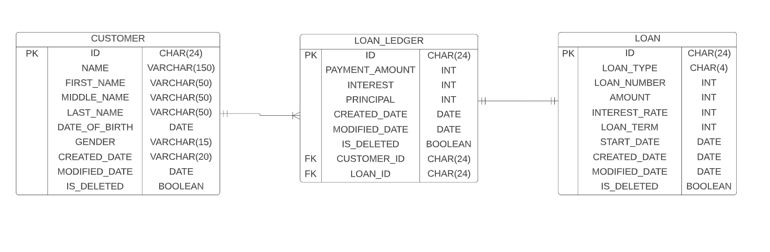

**Part 2: Requirement Storage Design Implementation: (DATABASE)**

**Ans:**

**Insert Records for 10 Customers**

Inserting through postman and checking in MongoDB

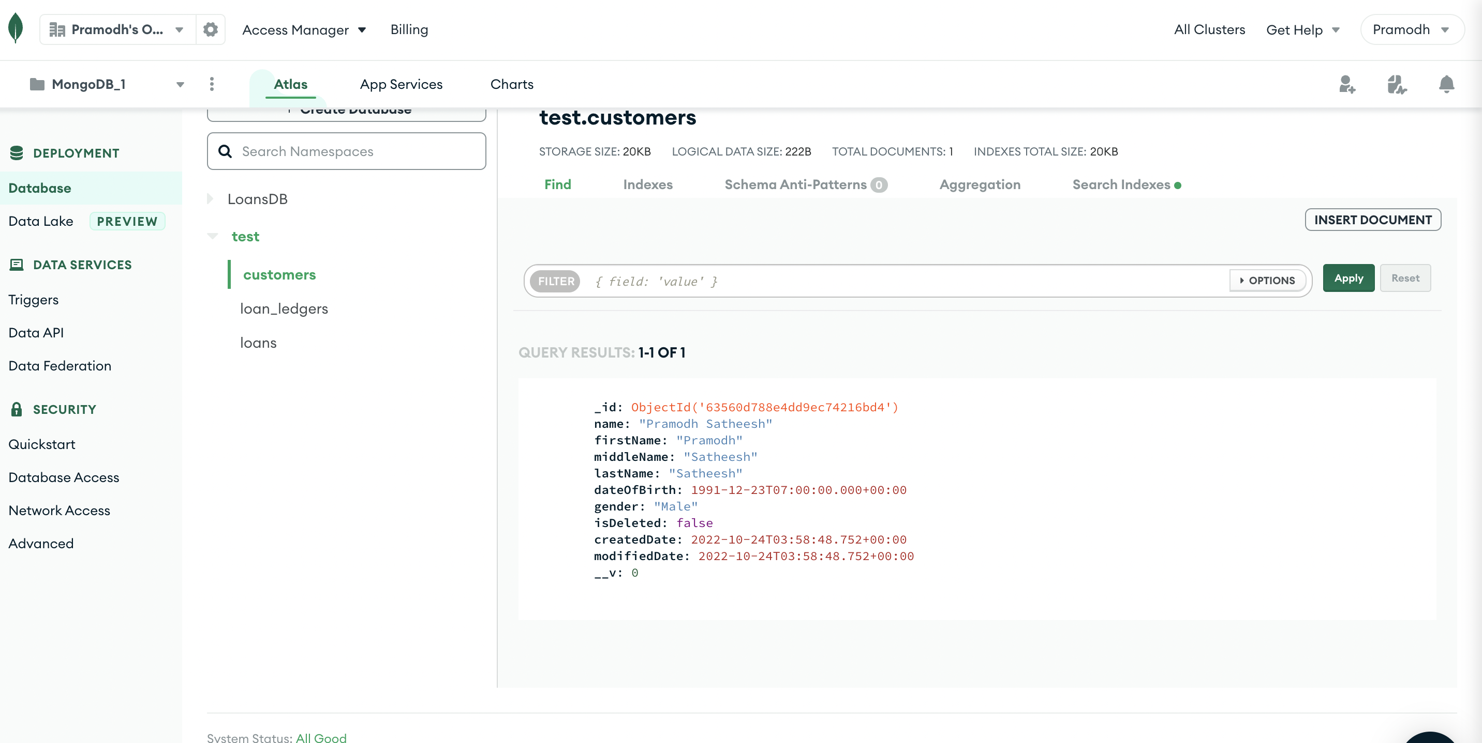

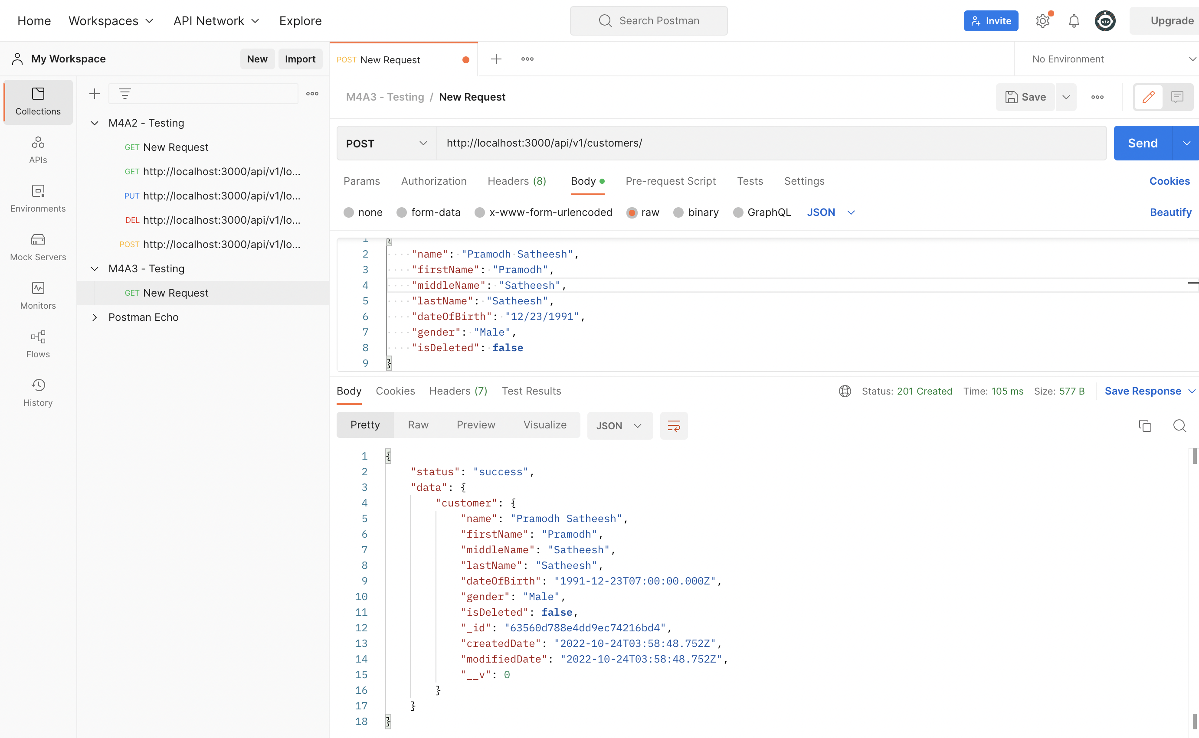

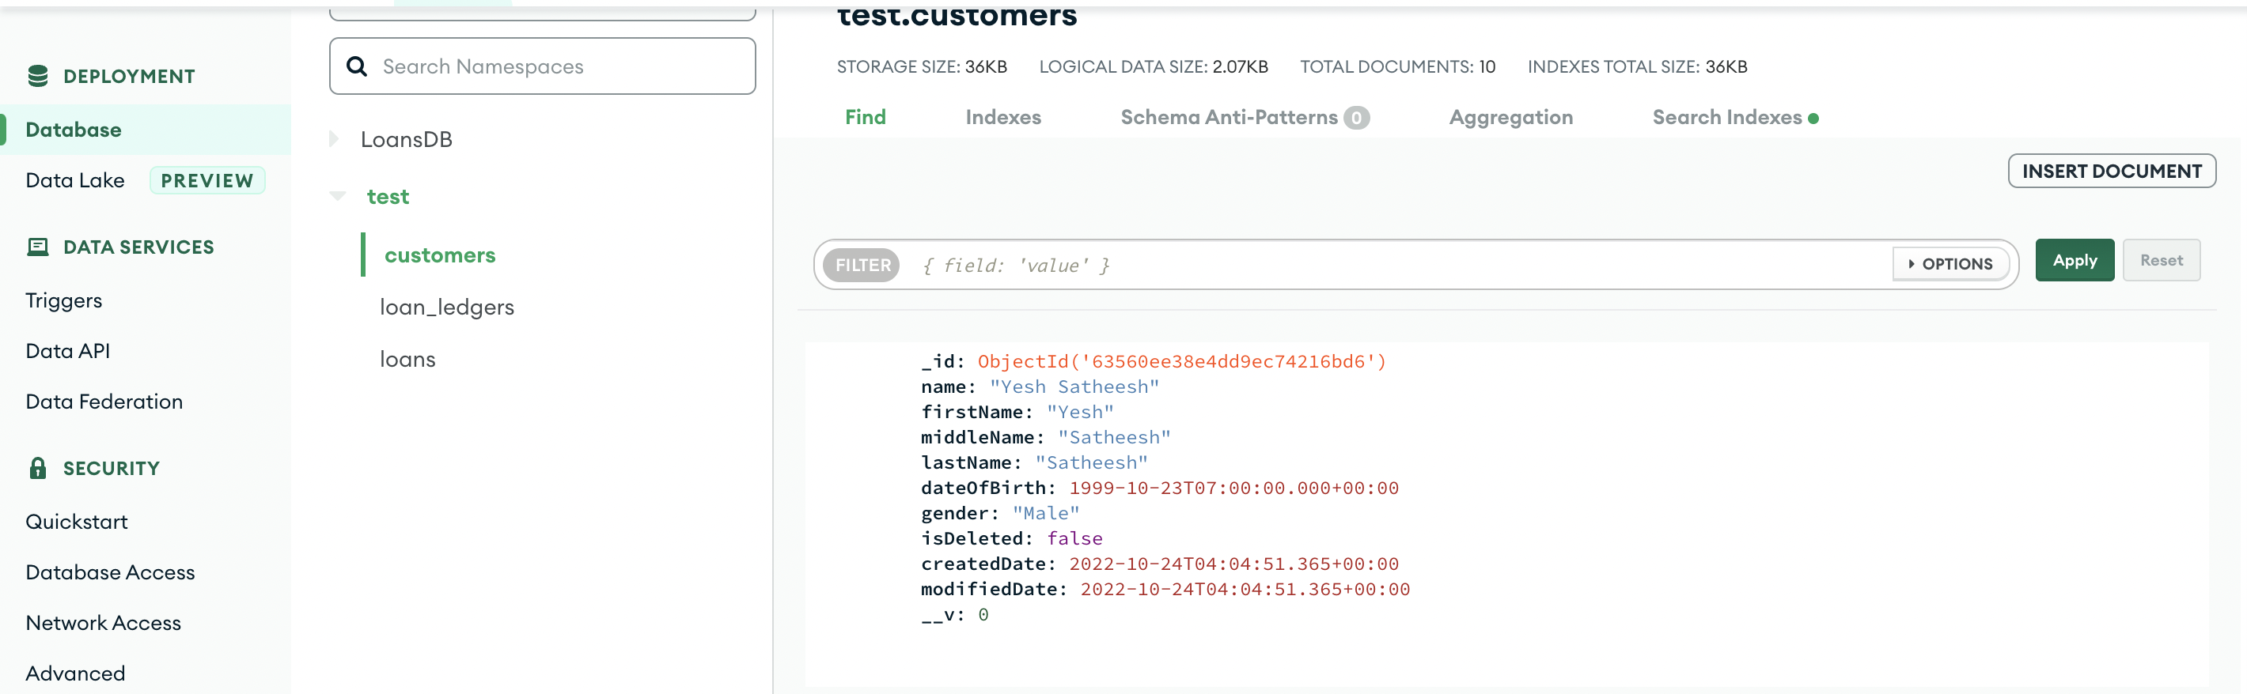

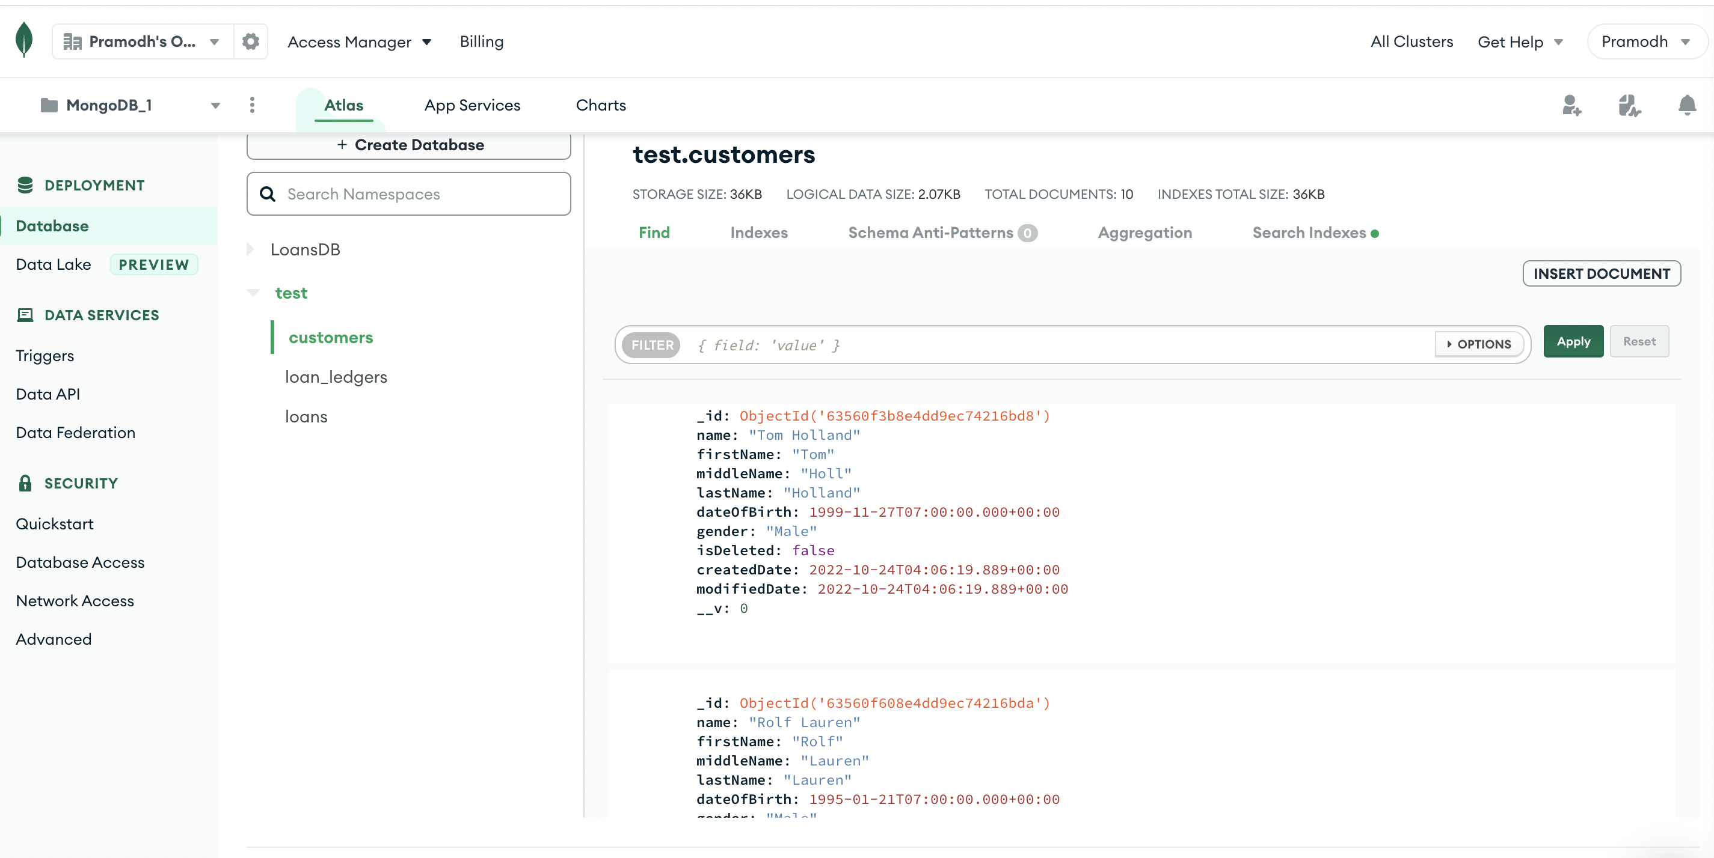

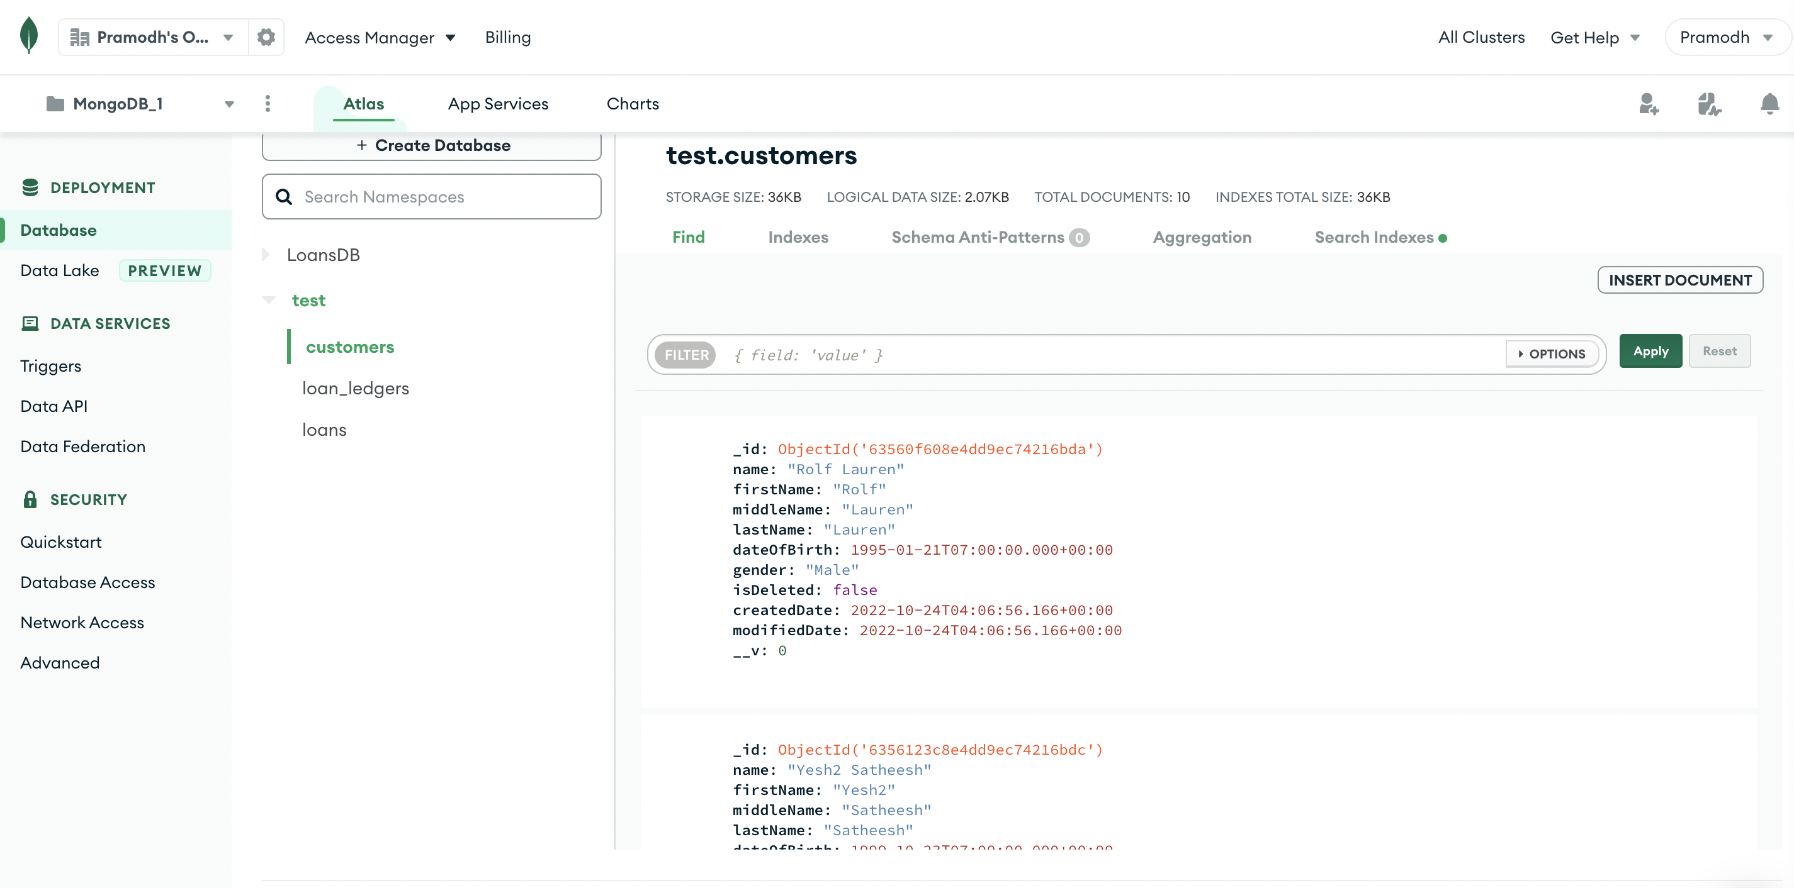

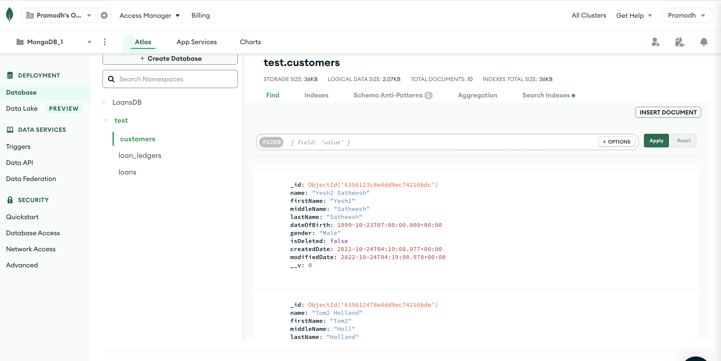

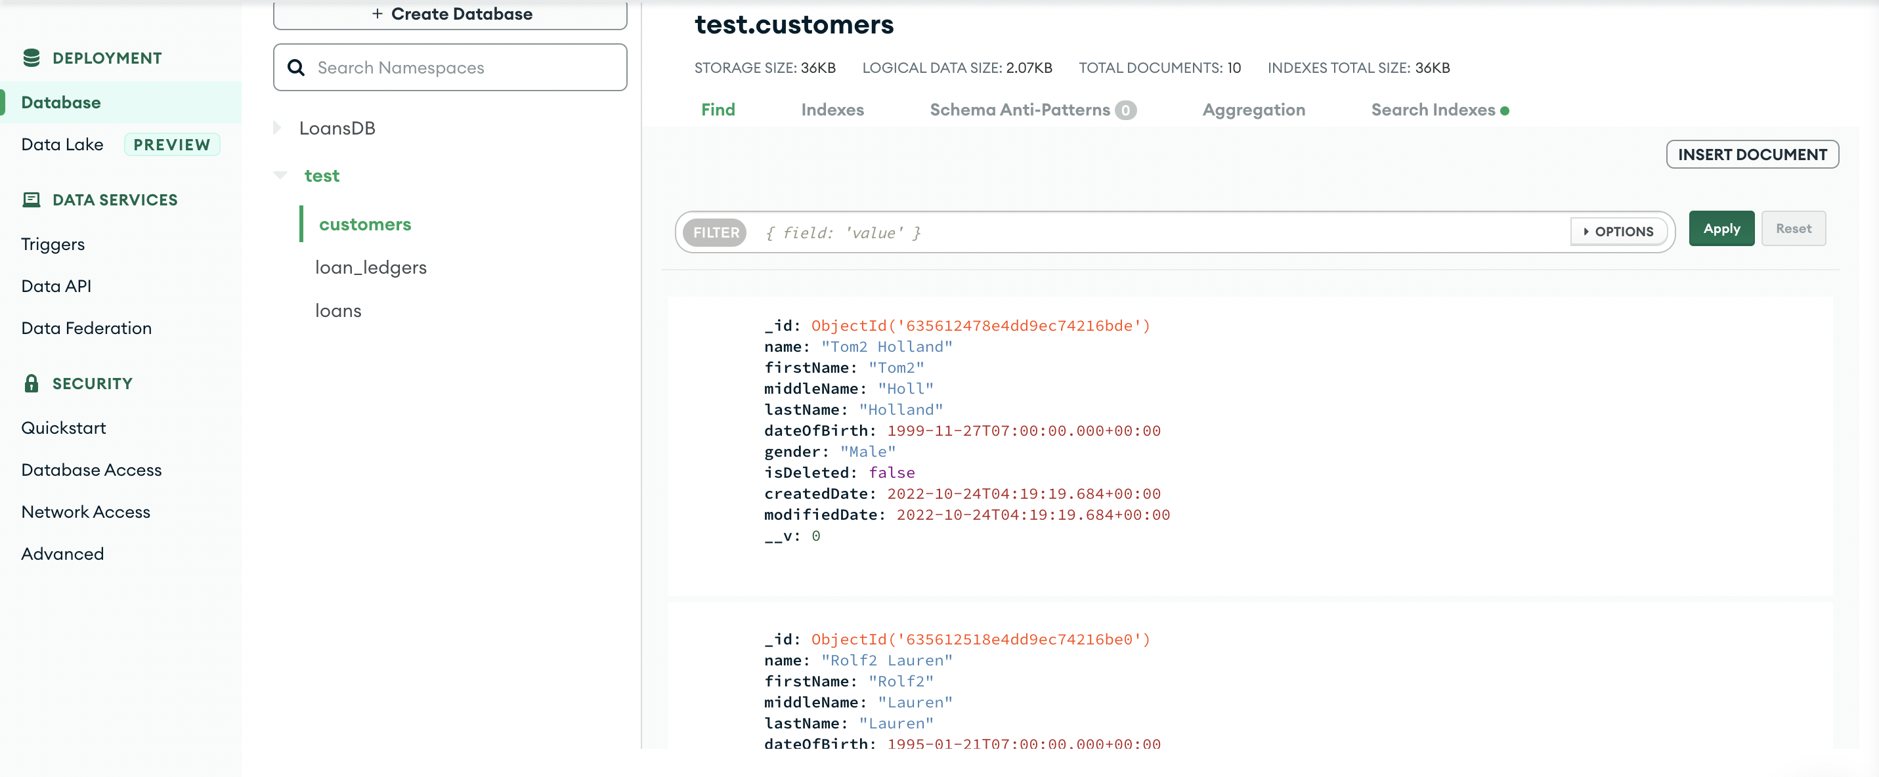

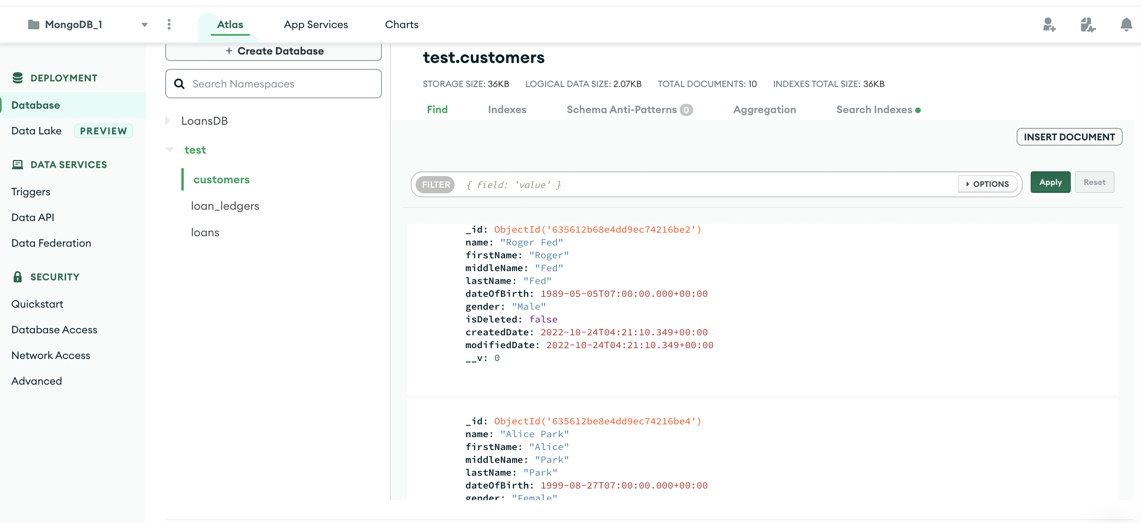

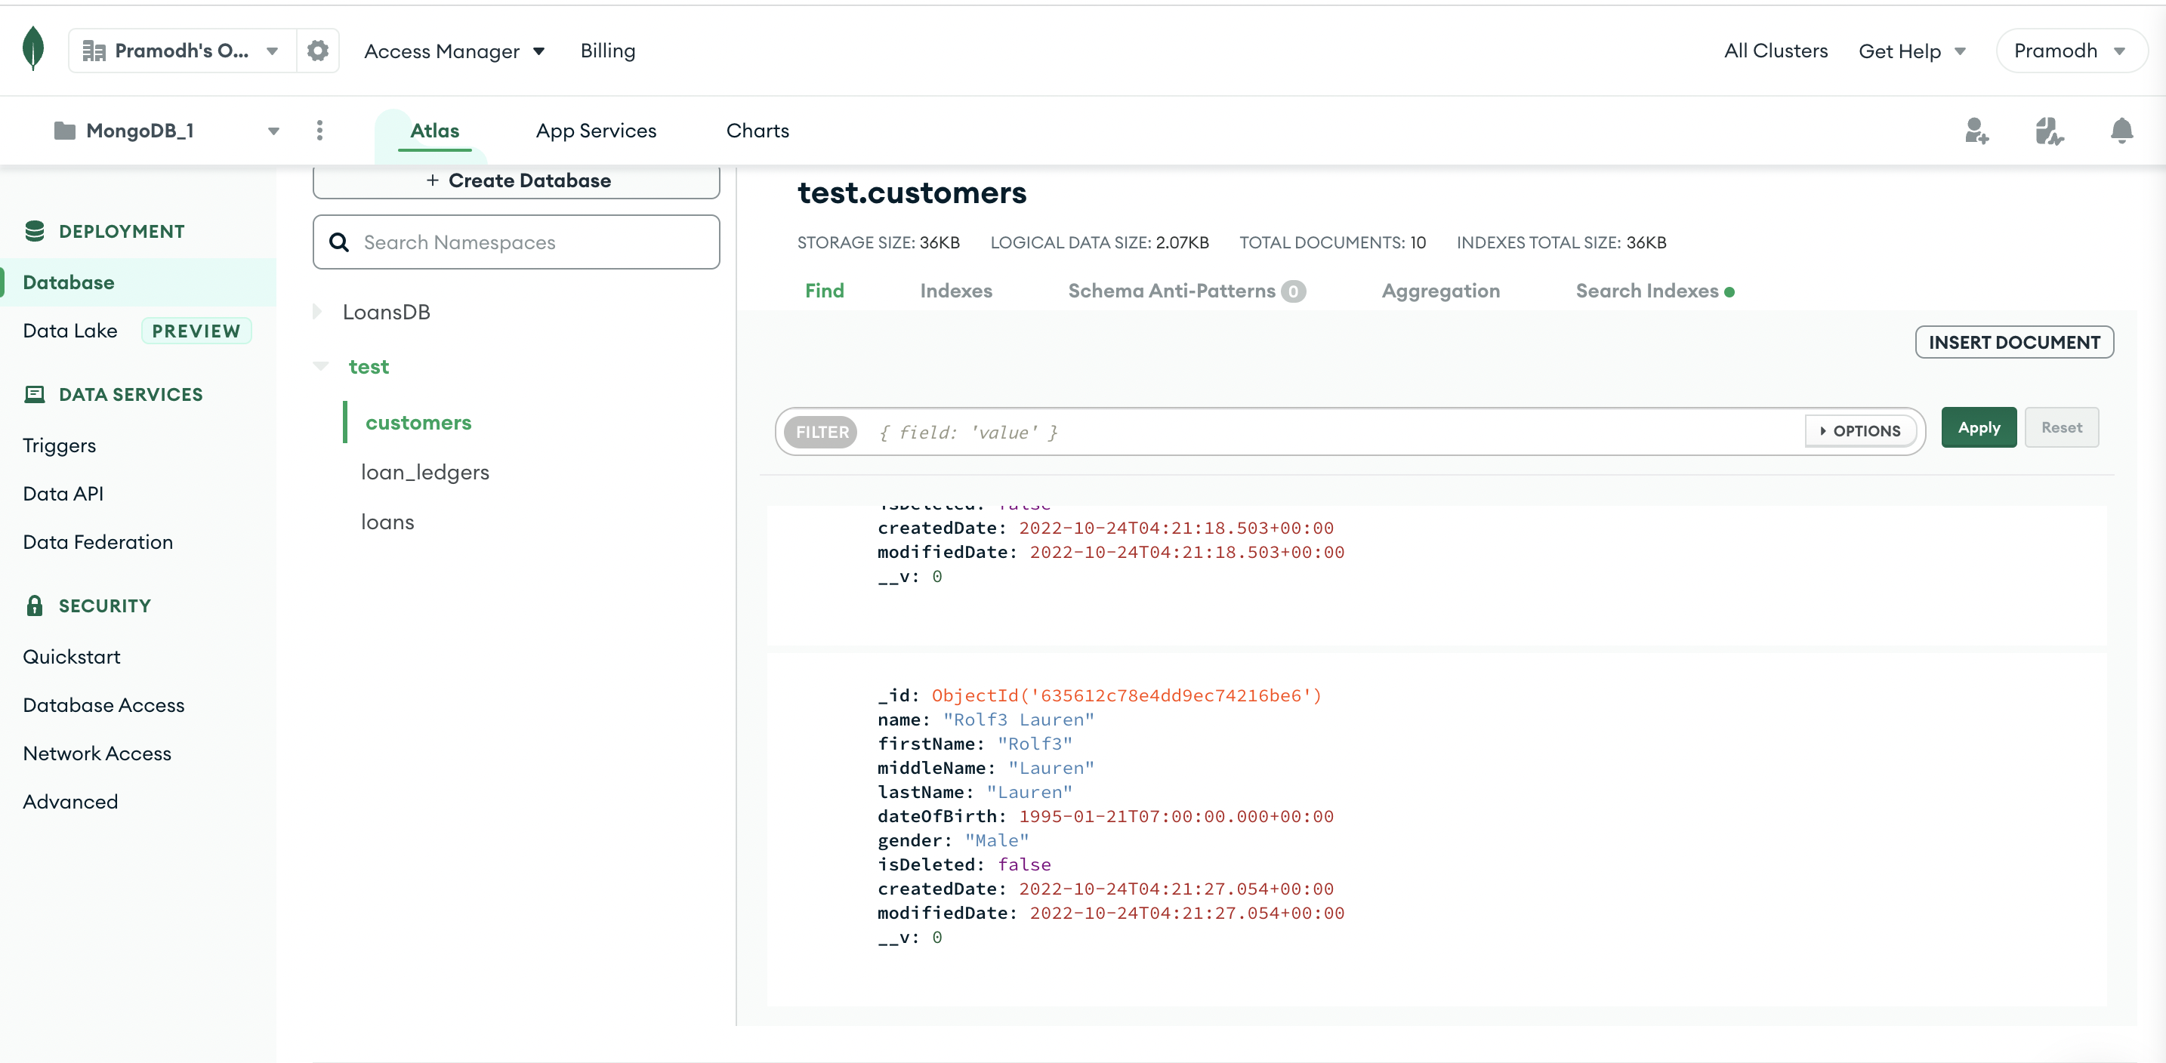

**Insert Records for 3 LoanTypes:**

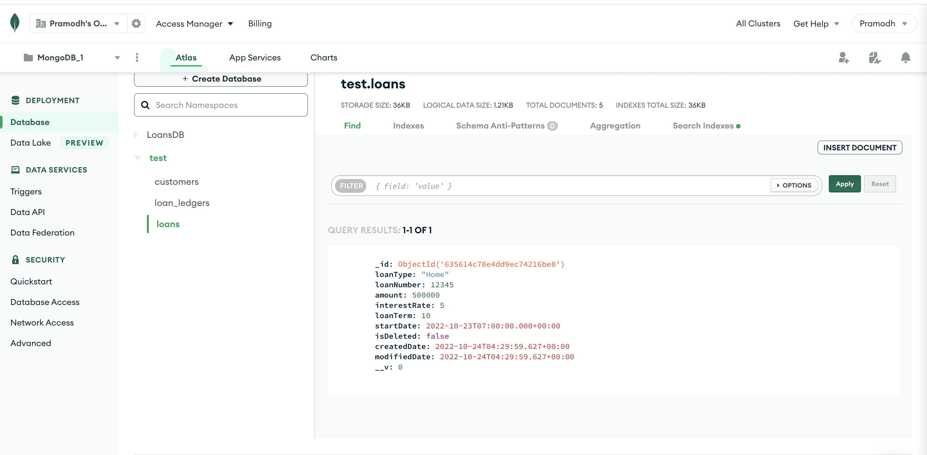

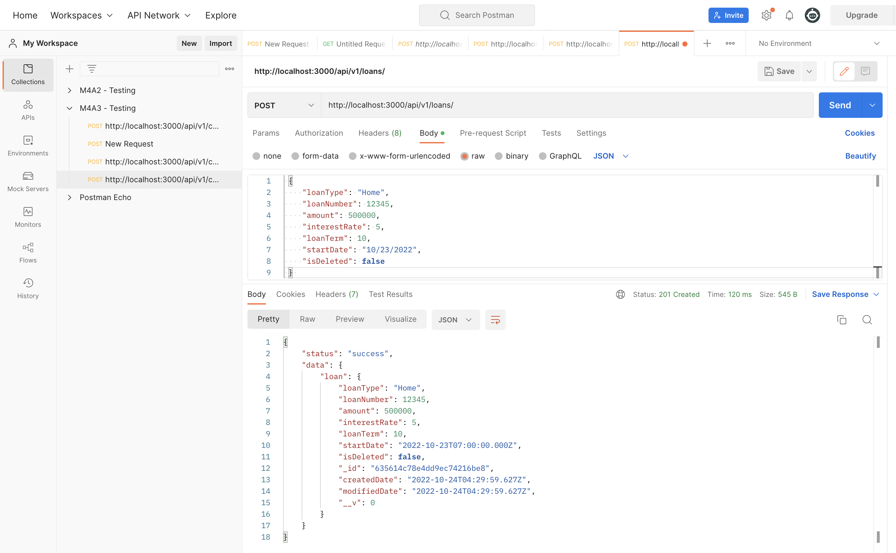

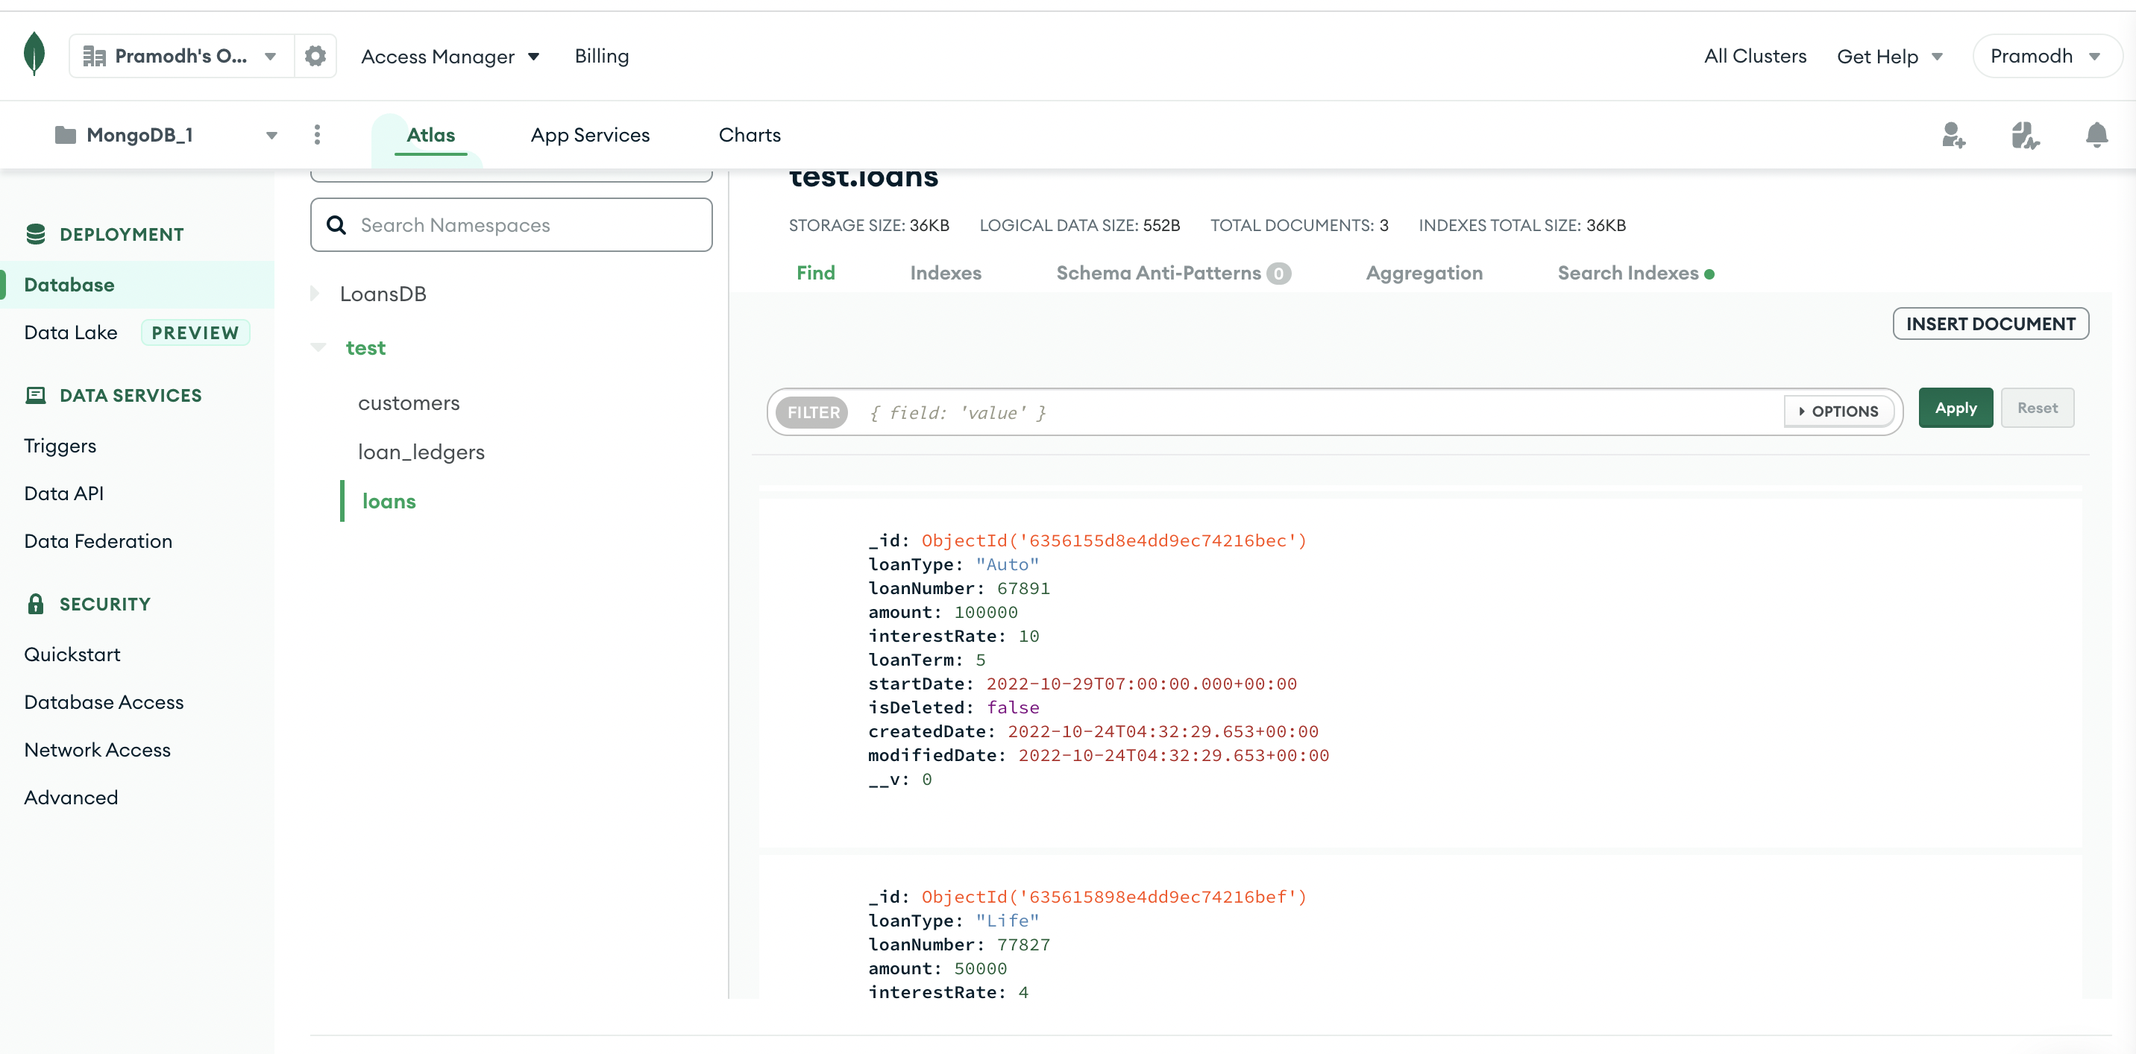

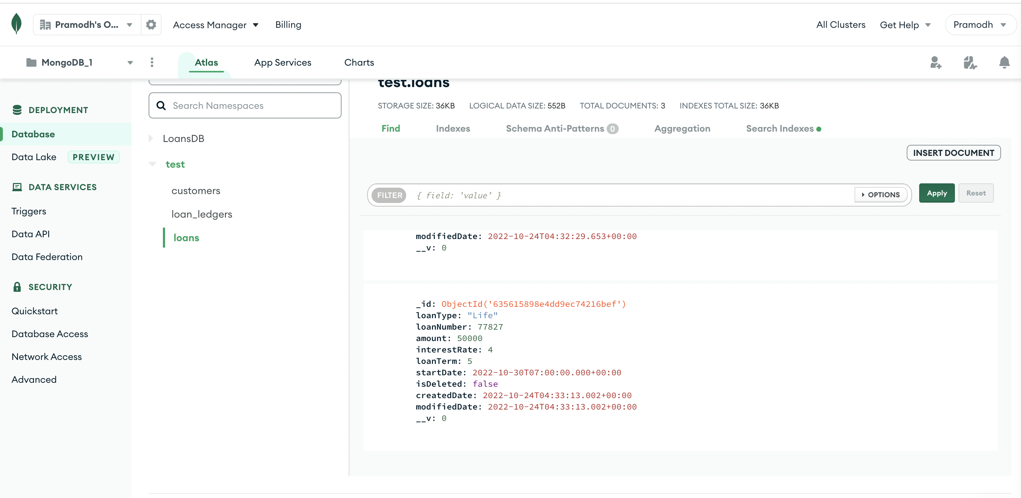

**Insert Records 2 Payments for 5 Customers with complete loan payments.**

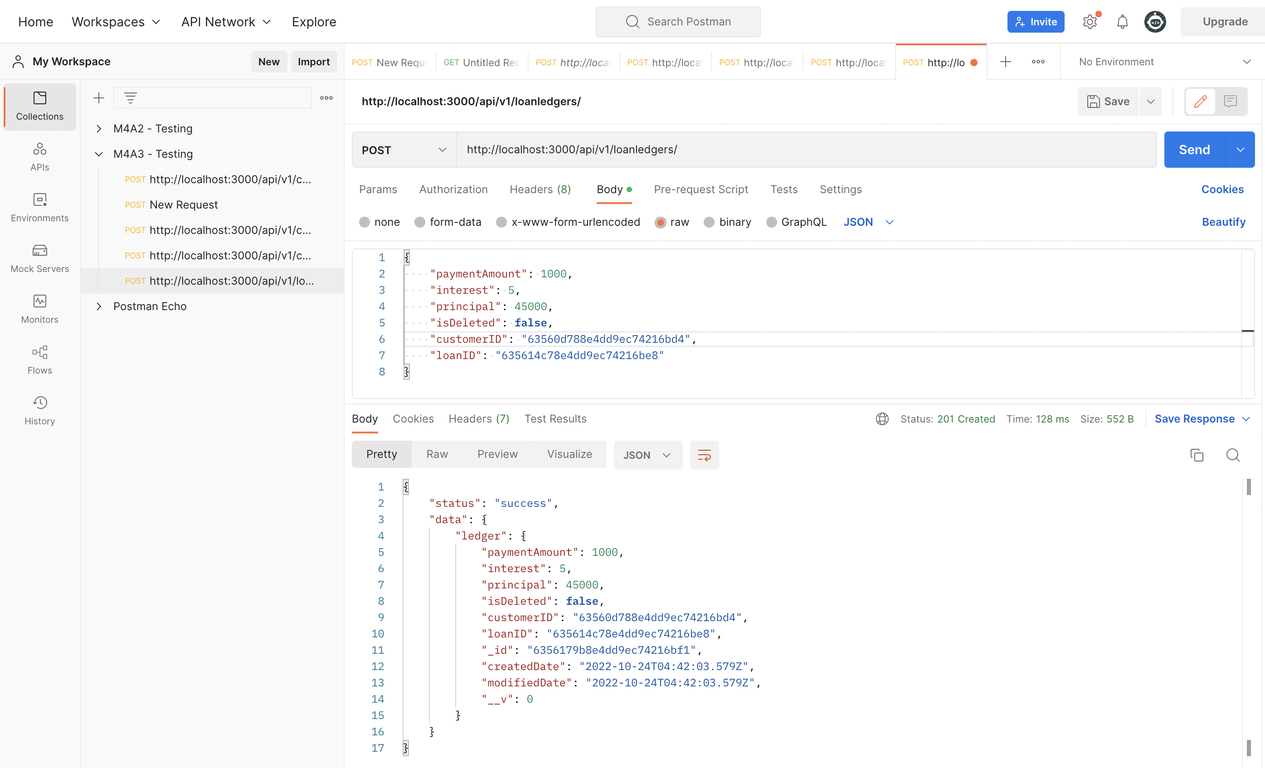

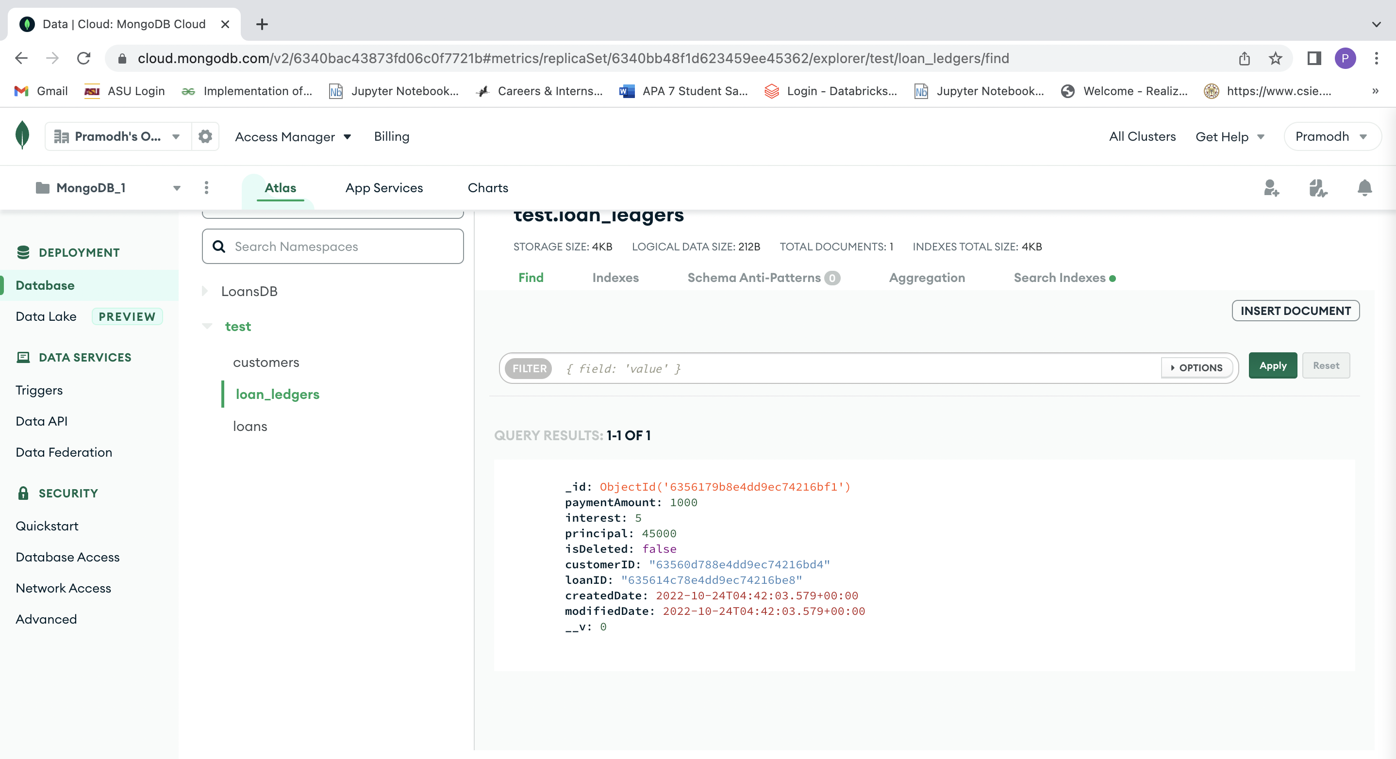

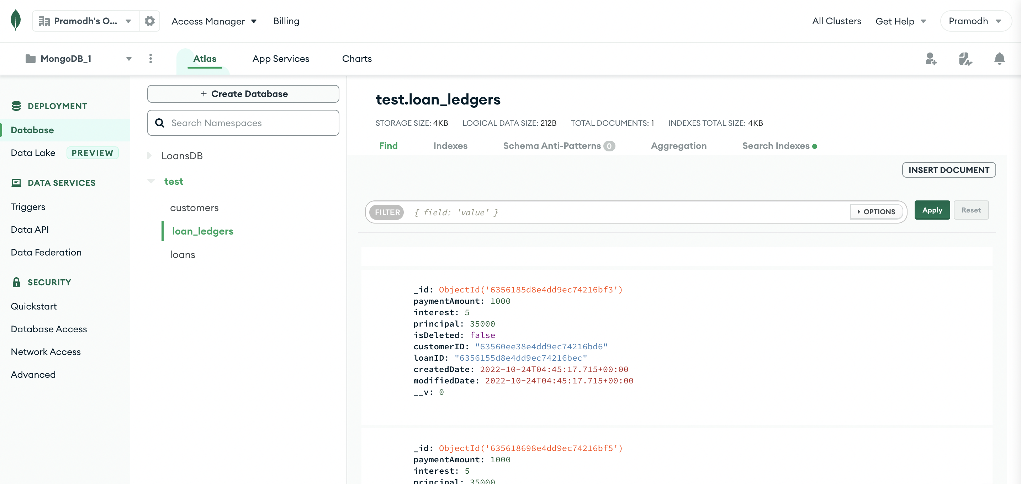

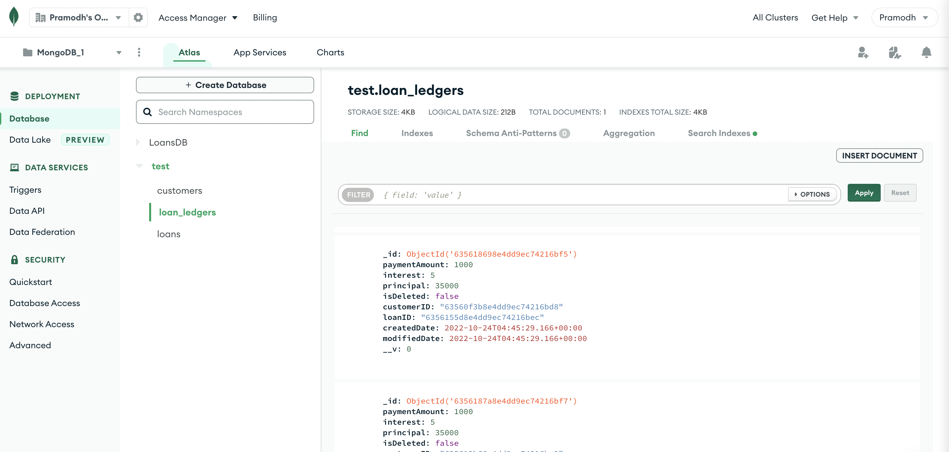

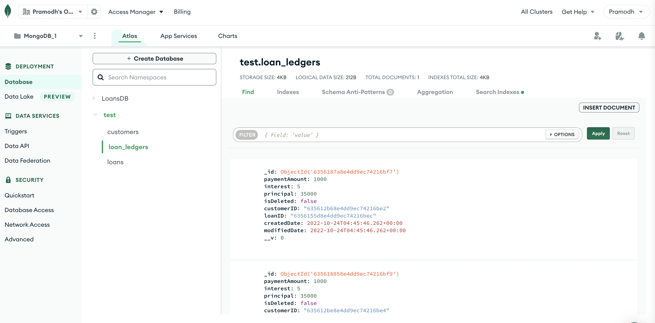

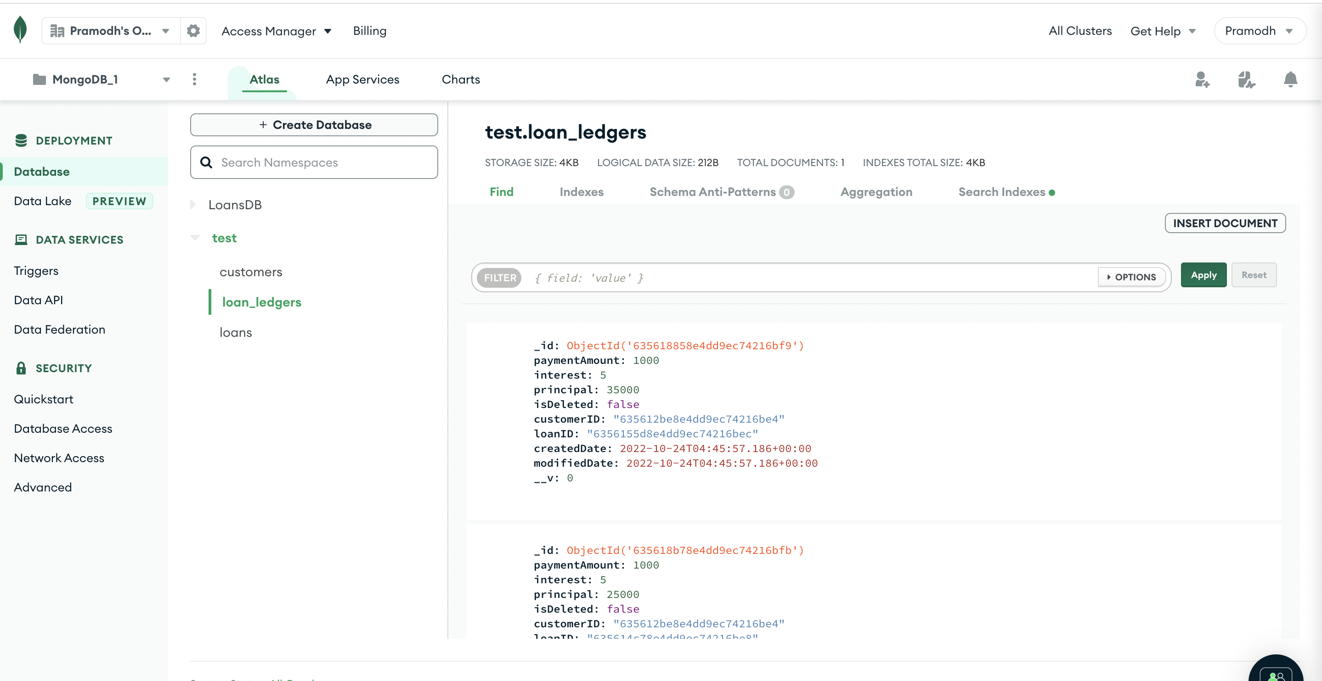

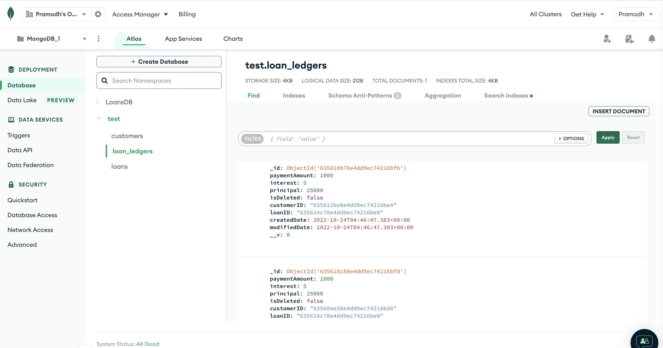

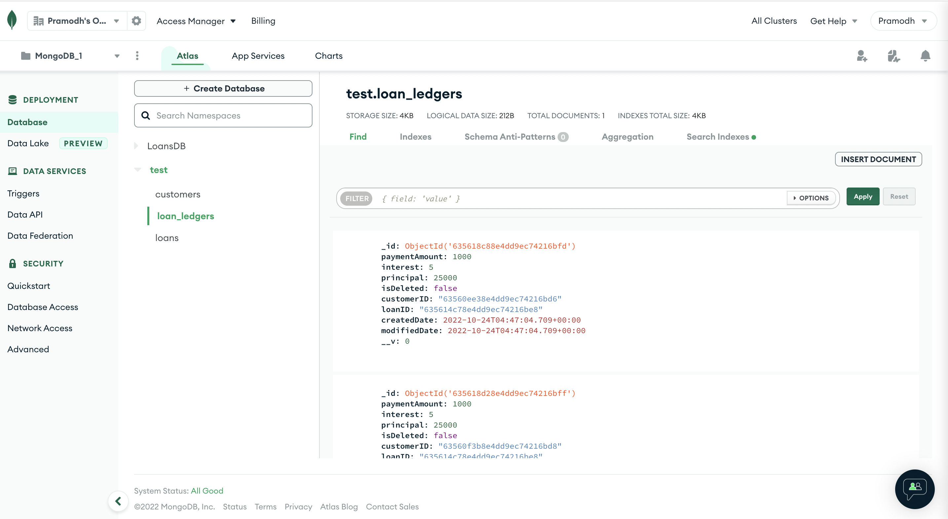

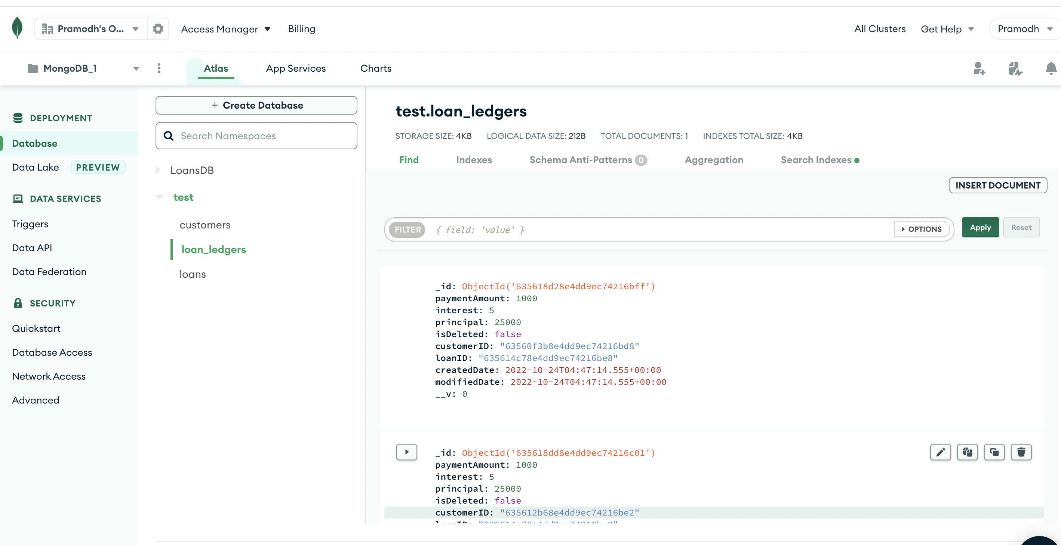

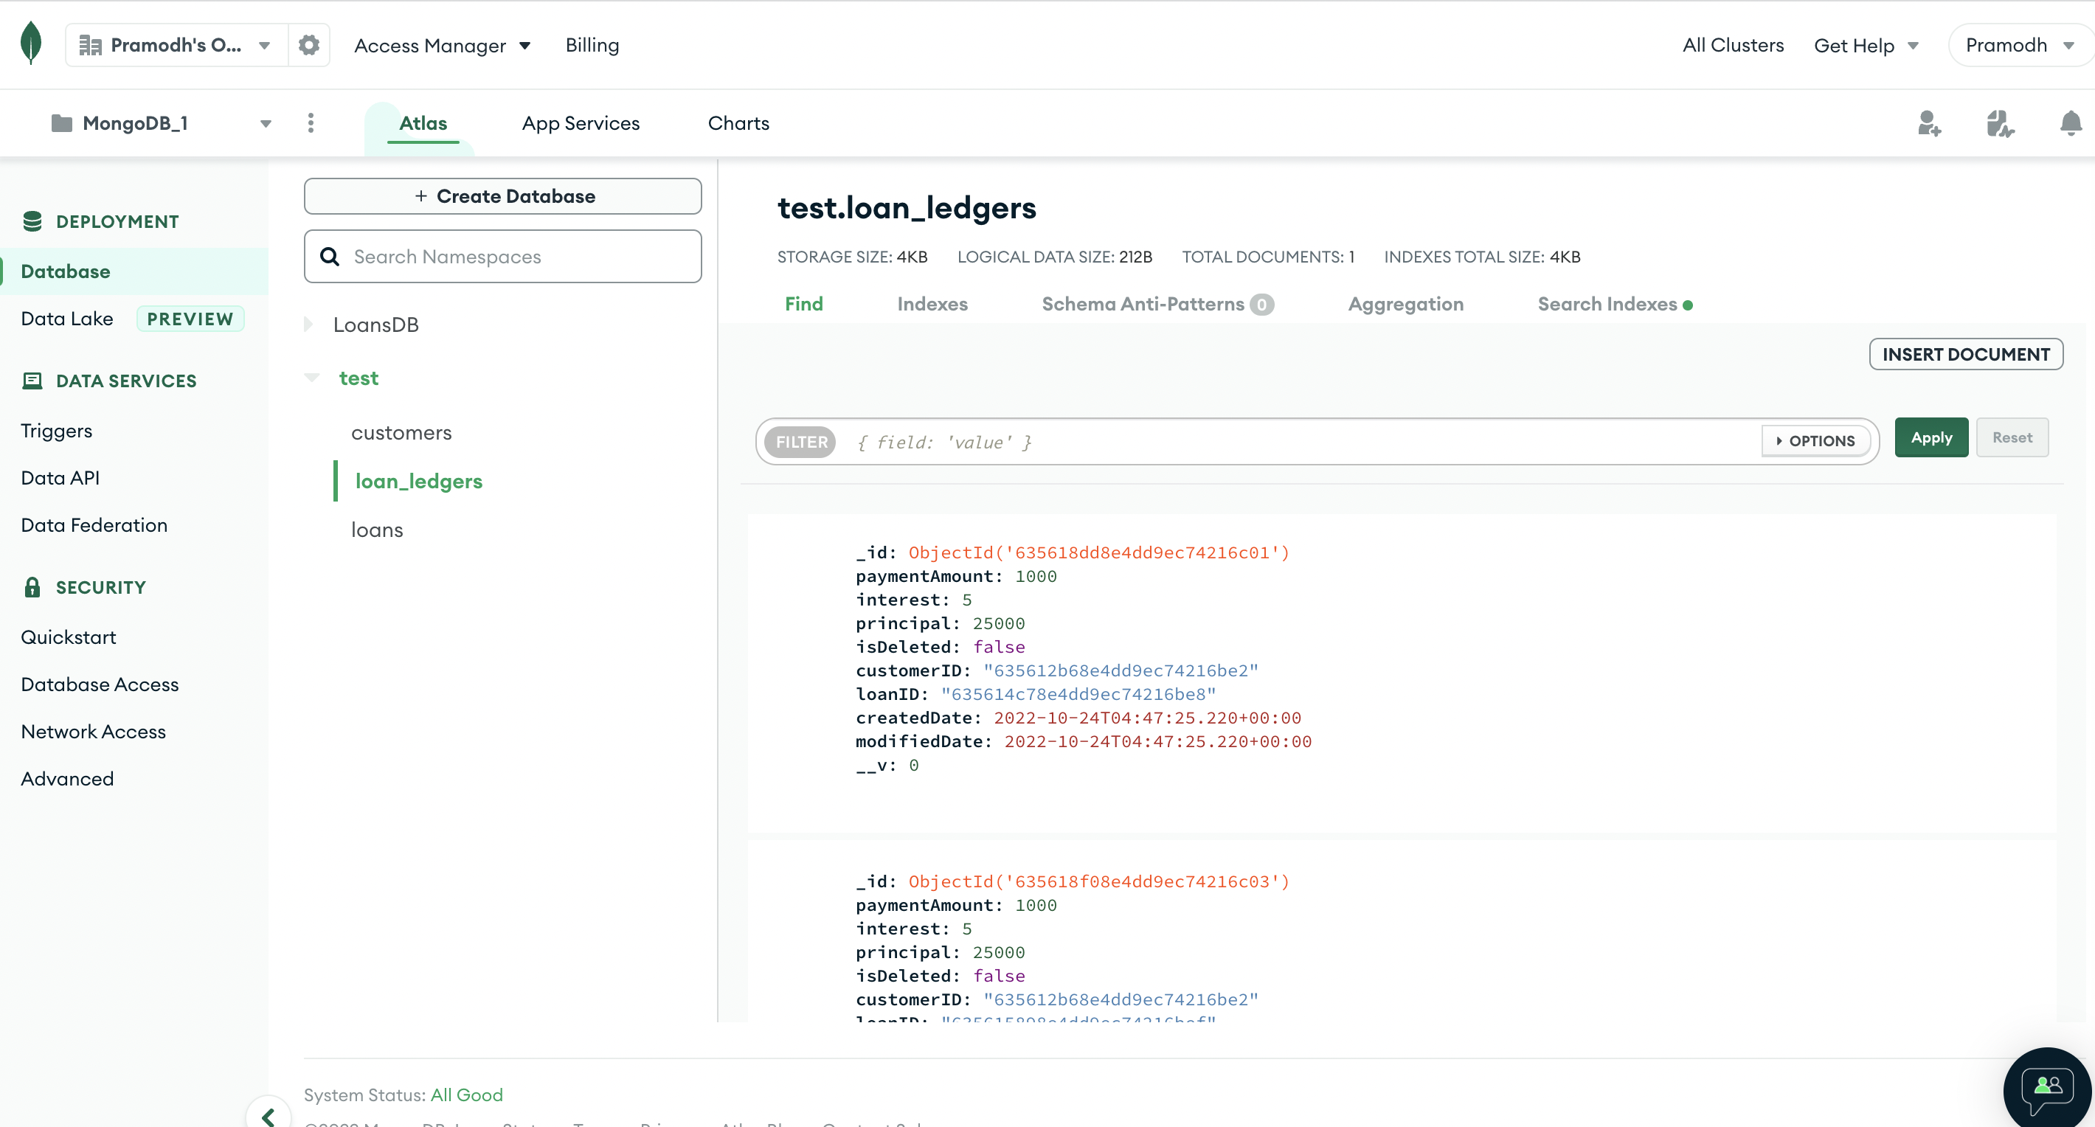

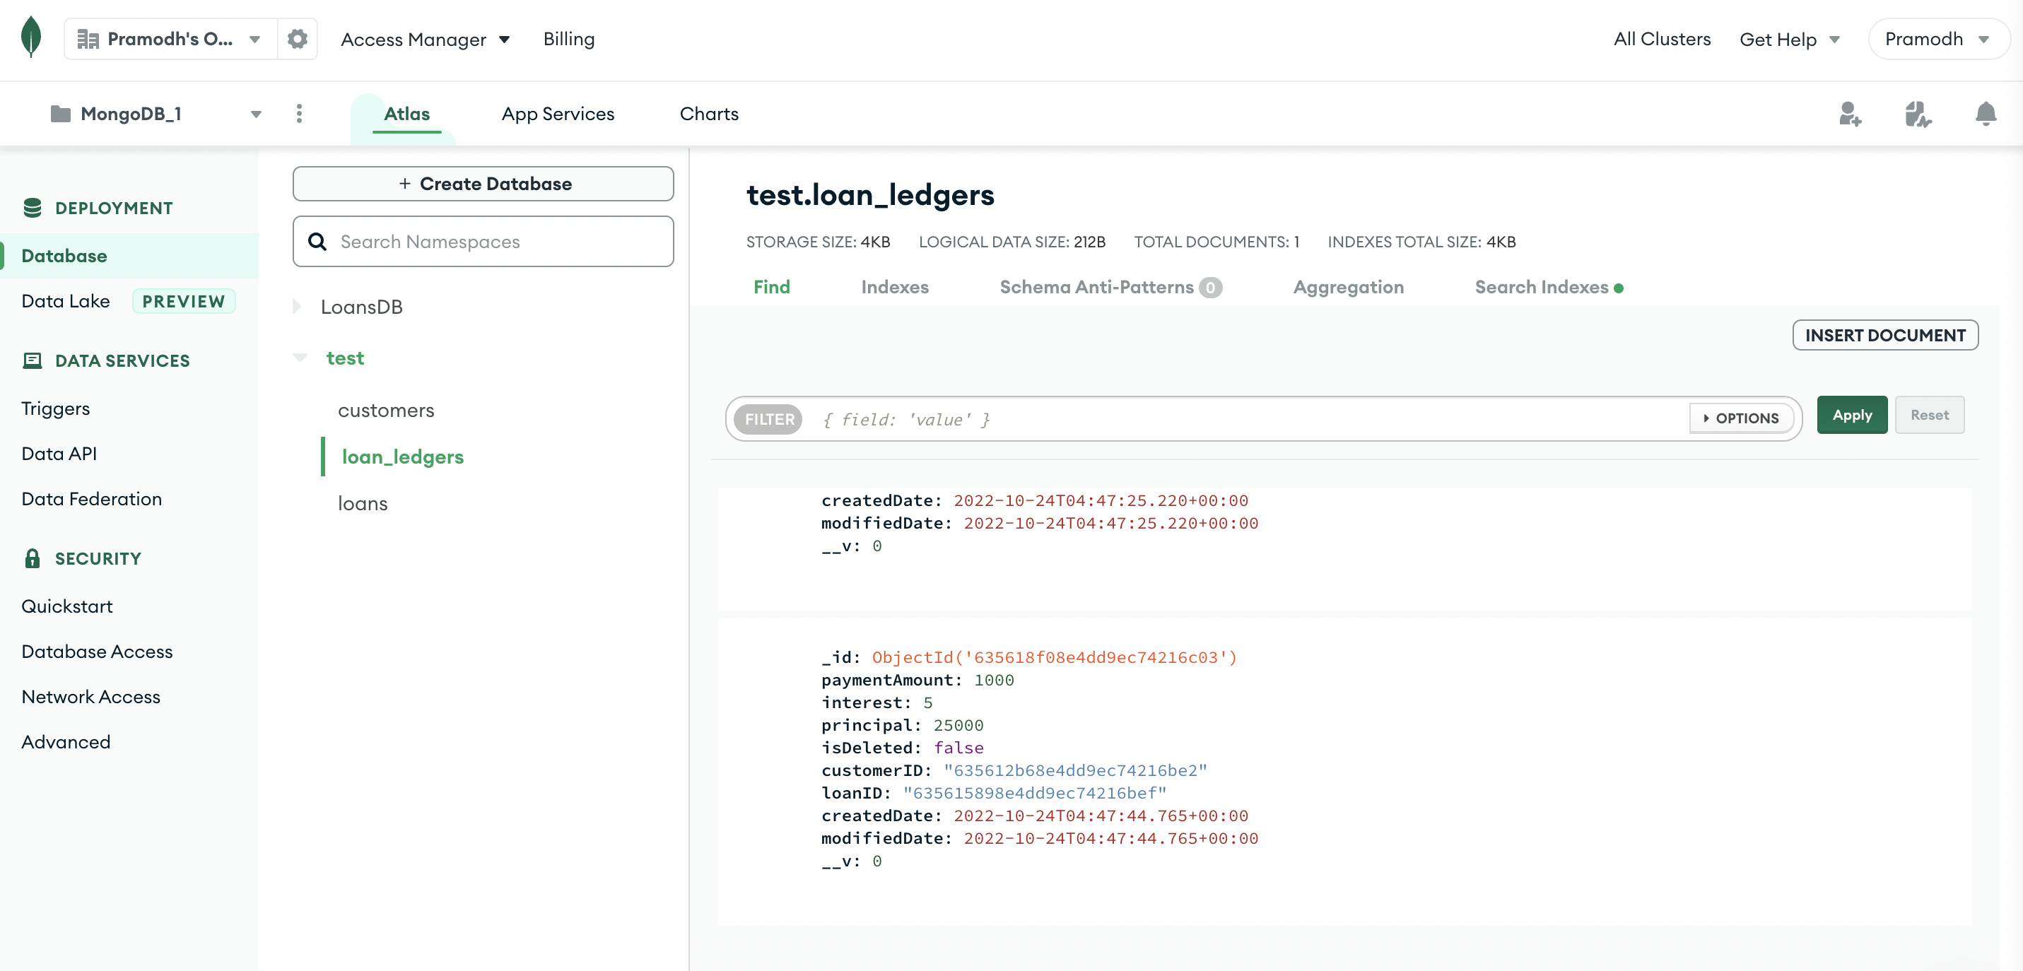

**Part 3: Requirement Storage Design Implementation: (DATABASE)**

**Create a Node.js Project to Access, and implement using Rest methods. Document and comment on all parts of the code and implementations as you see fit.**

customerController.js

Code:

const Customer = require('./../model/customerModel');

const APIFeatures = require('./../dataBaseManager/loanDbContext');

// Add a new customer

exports.createCustomer = async (req, res) => {

try {

const newCustomer = await Customer.create(req.body);

res.status(201).json({

status: 'success',

data: {

customer: newCustomer

}

});

} catch (err) {

res.status(400).json({

status: 'fail',

message: err

});

}

};

// Get All customers

exports.getAllCustomers = async (req, res) => {

try {

// EXECUTE QUERY

const features = new APIFeatures(Customer.find(), req.query)

.filter()

.sort()

.limitFields()

.paginate();

const customers = await features.query;

// SEND RESPONSE

res.status(200).json({

status: 'success',

results: customers.length,

data: {

customers

}

});

} catch (err) {

res.status(404).json({

status: 'fail',

message: err

});

}

};

// Get a Specific customer By ID

exports.getCustomer = async (req, res) => {

try {

const customer = await Customer.findById(req.params.id);

res.status(200).json({

status: 'success',

data: {

customer

}

});

} catch (err) {

res.status(404).json({

status: 'fail',

message: err

});

}

};

// Change an Existing customer record

exports.updateCustomer = async (req, res) => {

try {

const customer = await Customer.findByIdAndUpdate(req.params.id, req.body, {

new: true,

runValidators: true

});

res.status(200).json({

status: 'success',

data: {

customer

}

});

} catch (err) {

res.status(404).json({

status: 'fail',

message: err

});

}

};

// Delete a customer

exports.deleteCustomer = async (req, res) => {

try {

await Customer.findByIdAndDelete(req.params.id);

res.status(204).json({

status: 'success',

data: "Customer record deleted successfully"

});

} catch (err) {

res.status(404).json({

status: 'fail',

message: err

});

}

};

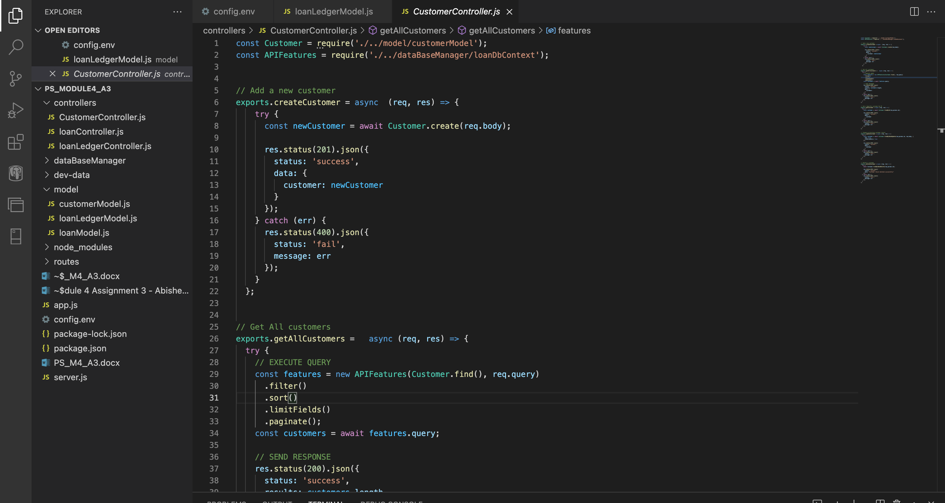

LoanController.js

Code:

const Loan = require('./../model/loanModel');

const APIFeatures = require('./../dataBaseManager/loanDbContext');

// Add a new loan

exports.createLoan = async (req, res) => {

try {

const newLoan = await Loan.create(req.body);

res.status(201).json({

status: 'success',

data: {

loan: newLoan

}

});

} catch (err) {

res.status(400).json({

status: 'fail',

message: err

});

}

};

// Get All Loans

exports.getAllLoans = async (req, res) => {

try {

// EXECUTE QUERY

const features = new APIFeatures(Loan.find(), req.query)

.filter()

.sort()

.limitFields()

.paginate();

const loans = await features.query;

// SEND RESPONSE

res.status(200).json({

status: 'success',

results: loans.length,

data: {

loans

}

});

} catch (err) {

res.status(404).json({

status: 'fail',

message: err

});

}

};

// Get a Specific Loan By ID

exports.getLoan = async (req, res) => {

try {

const loan = await Loan.findById(req.params.id);

res.status(200).json({

status: 'success',

data: {

loan

}

});

} catch (err) {

res.status(404).json({

status: 'fail',

message: err

});

}

};

// Change an Existing Loan

exports.updateLoan = async (req, res) => {

try {

const loan = await Loan.findByIdAndUpdate(req.params.id, req.body, {

new: true,

runValidators: true

});

res.status(200).json({

status: 'success',

data: {

loan

}

});

} catch (err) {

res.status(404).json({

status: 'fail',

message: err

});

}

};

// Delete a Loan

exports.deleteLoan = async (req, res) => {

try {

await Loan.findByIdAndDelete(req.params.id);

res.status(204).json({

status: 'success',

data: "Loan successfully deleted"

});

} catch (err) {

res.status(404).json({

status: 'fail',

message: err

});

}

};

loanLedgerController.js

const LoanLedger = require('./../model/loanLedgerModel');

const APIFeatures = require('./../dataBaseManager/loanDbContext');

// Add a new loan ledger

exports.createLedger = async (req, res) => {

try {

const newLedger = await LoanLedger.create(req.body);

res.status(201).json({

status: 'success',

data: {

ledger: newLedger

}

});

} catch (err) {

res.status(400).json({

status: 'fail',

message: err

});

}

};

// Get All Loan ledgers

exports.getAllLedgers = async (req, res) => {

try {

// EXECUTE QUERY

const features = new APIFeatures(LoanLedger.find(), req.query)

.filter()

.sort()

.limitFields()

.paginate();

const ledgers = await features.query;

// SEND RESPONSE

res.status(200).json({

status: 'success',

results: ledgers.length,

data: {

ledgers

}

});

} catch (err) {

res.status(404).json({

status: 'fail',

message: err

});

}

};

// Get a Specific Loan ledger By ID

exports.getLedger = async (req, res) => {

try {

const ledger = await LoanLedger.findById(req.params.id);

res.status(200).json({

status: 'success',

data: {

ledger

}

});

} catch (err) {

res.status(404).json({

status: 'fail',

message: err

});

}

};

// Change an Existing Loan ledger

exports.updateLedger = async (req, res) => {

try {

const ledger = await LoanLedger.findByIdAndUpdate(req.params.id, req.body, {

new: true,

runValidators: true

});

res.status(200).json({

status: 'success',

data: {

ledger

}

});

} catch (err) {

res.status(404).json({

status: 'fail',

message: err

});

}

};

// Delete a Loan ledger

exports.deleteLedger = async (req, res) => {

try {

await LoanLedger.findByIdAndDelete(req.params.id);

res.status(204).json({

status: 'success',

data: "Loan ledger successfully deleted"

});

} catch (err) {

res.status(404).json({

status: 'fail',

message: err

});

}

};

Models:

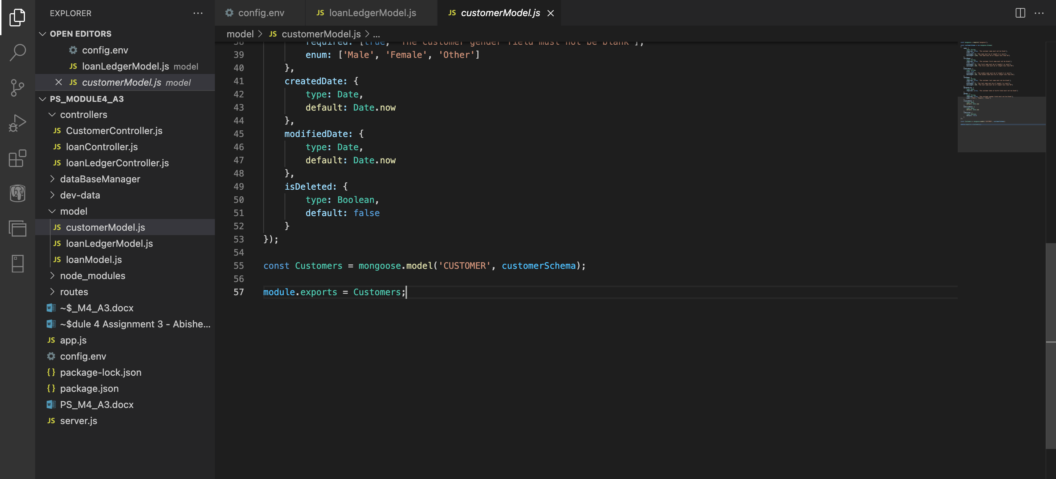

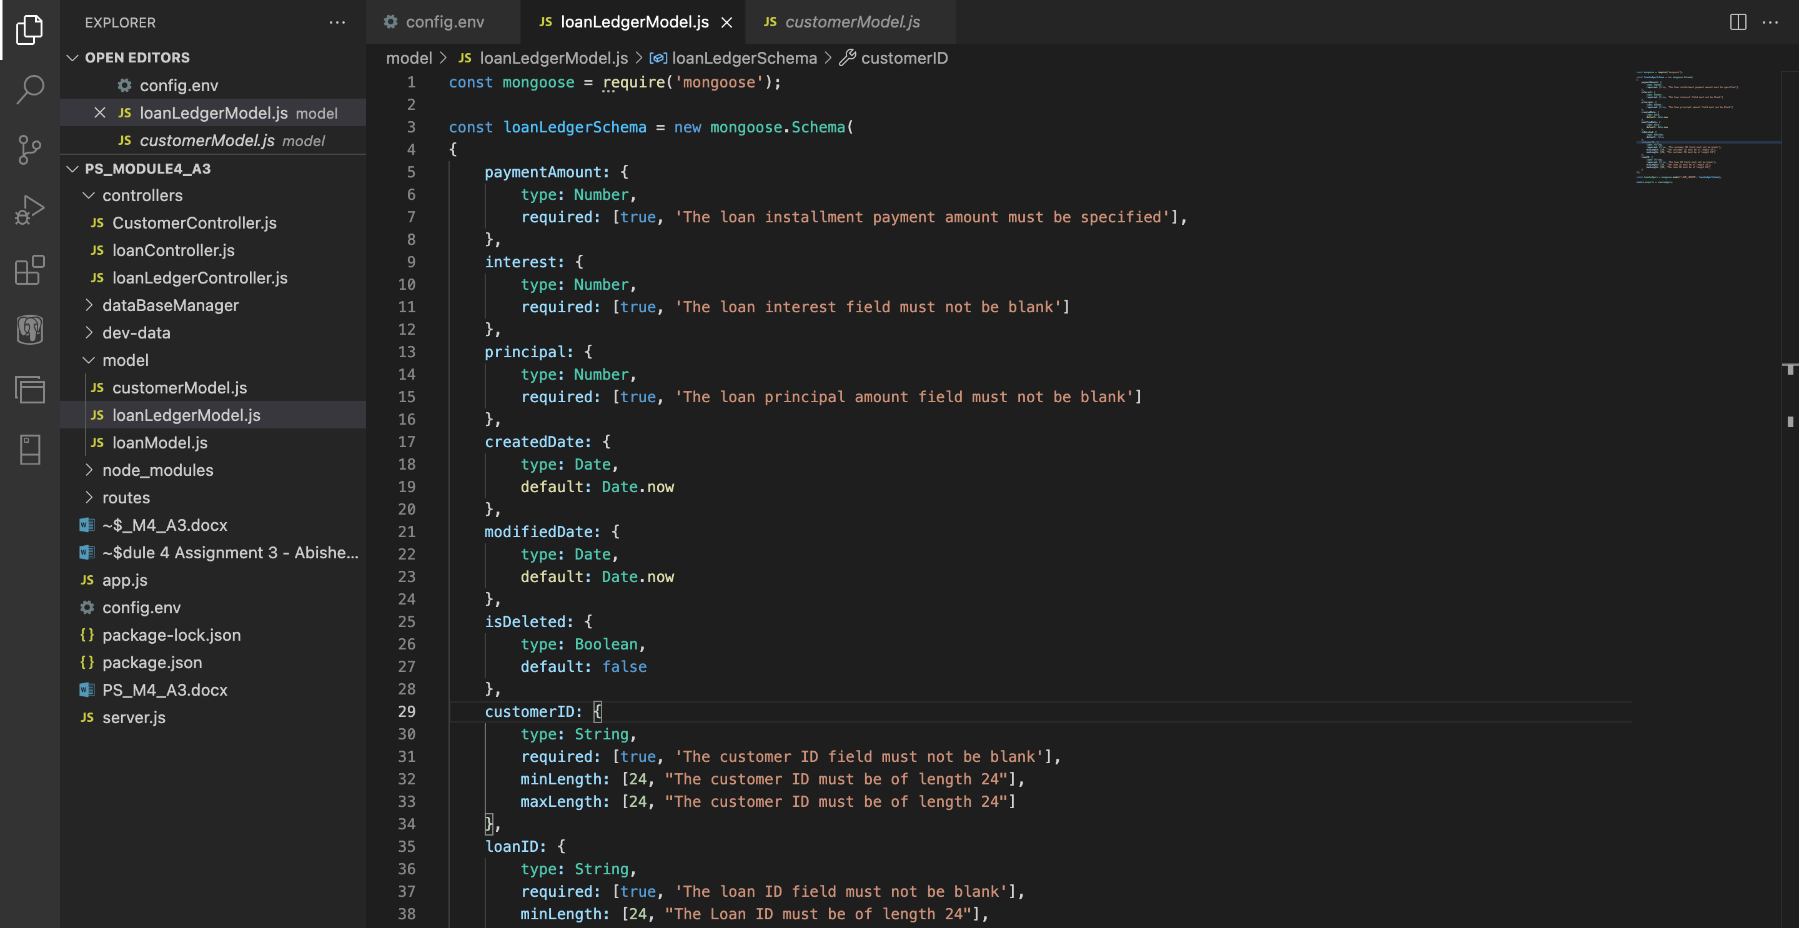

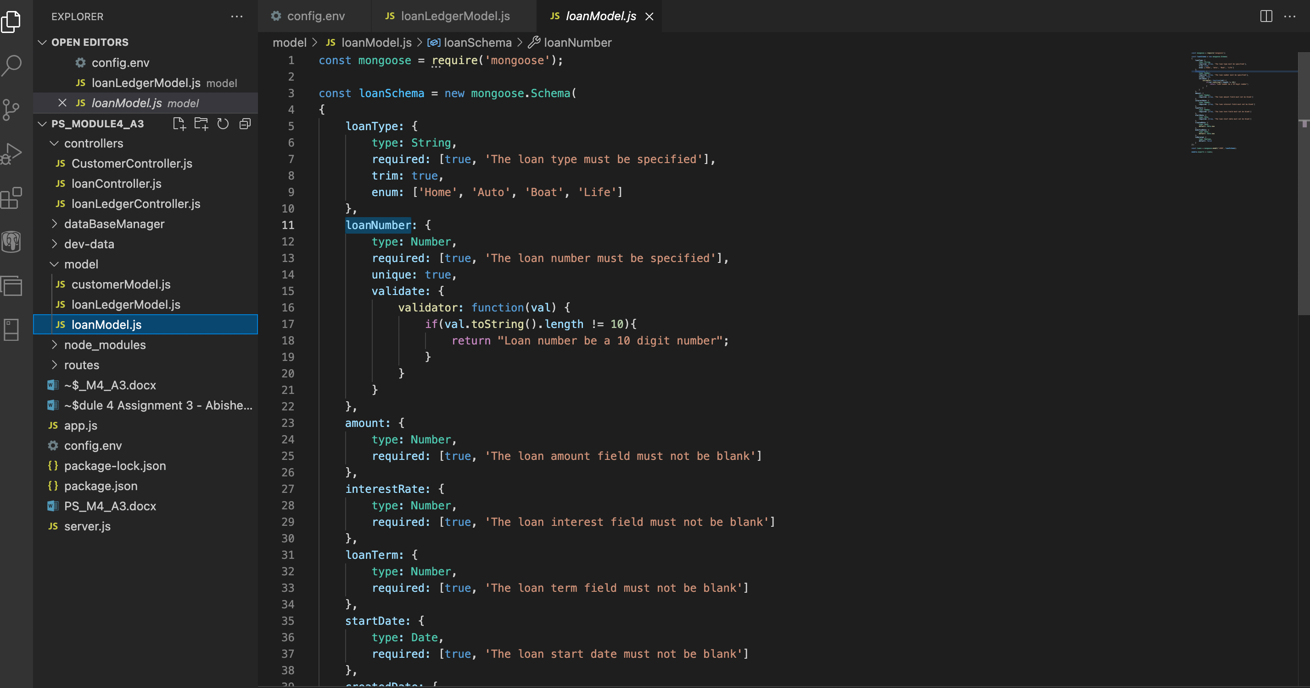

Code Execution:

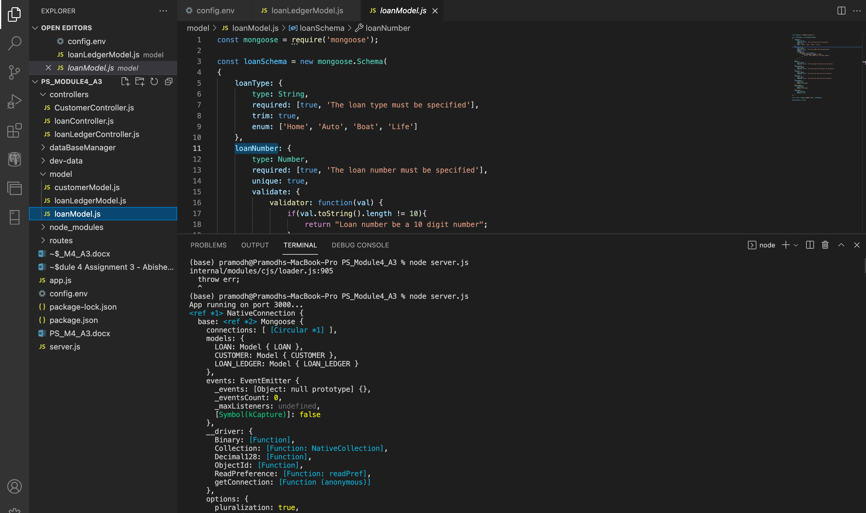

Database connection Establishment:

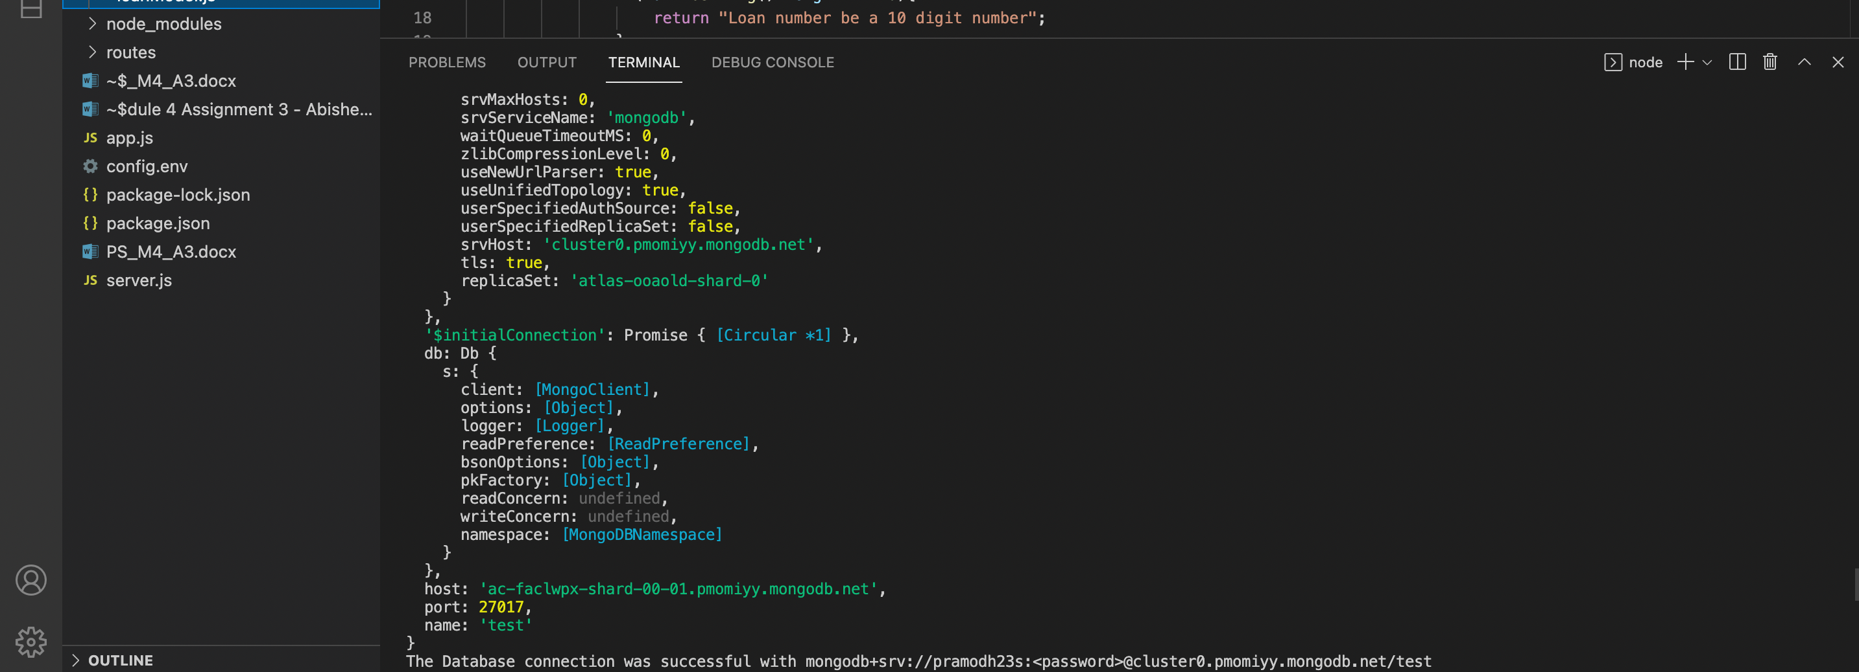

**Part 4: Use POSTMAN as a client application to test your App server and the Middleware.**

SELECT ( Get),

INSERT( Post)

UPDATE (Update)

and DELETE (Delete)

**Customers Table:**

Select All:

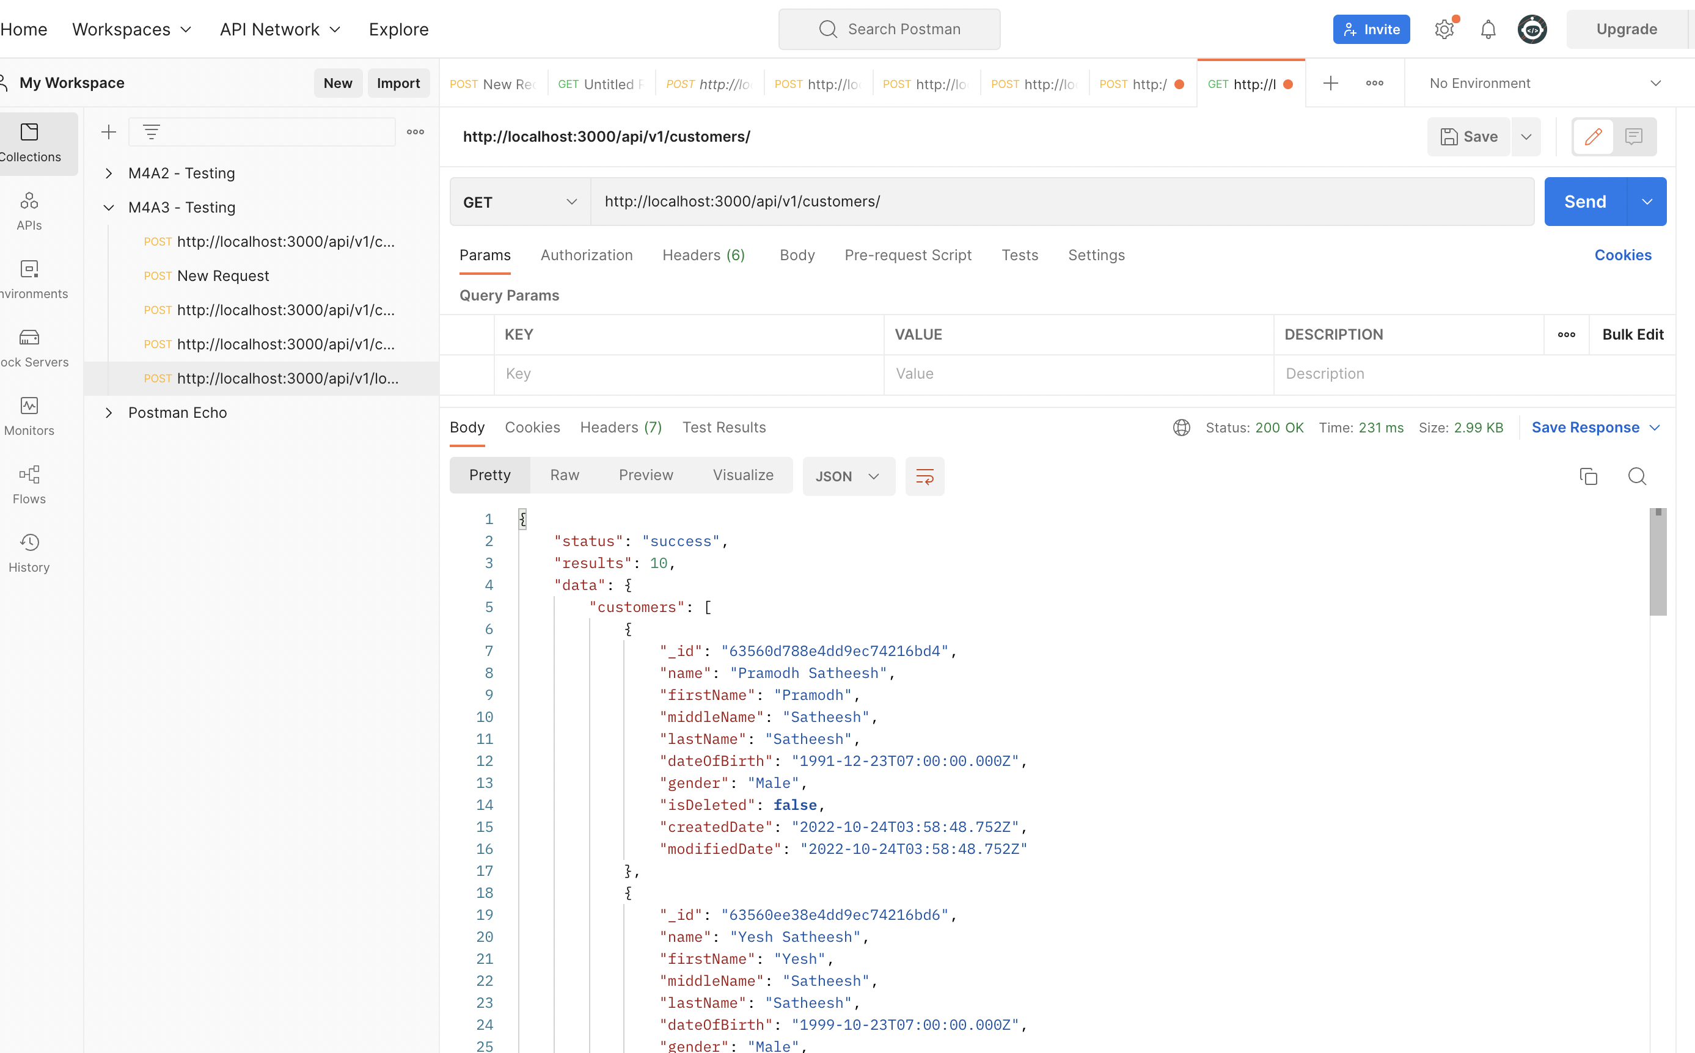

* **SELECT a customer based on the ID**

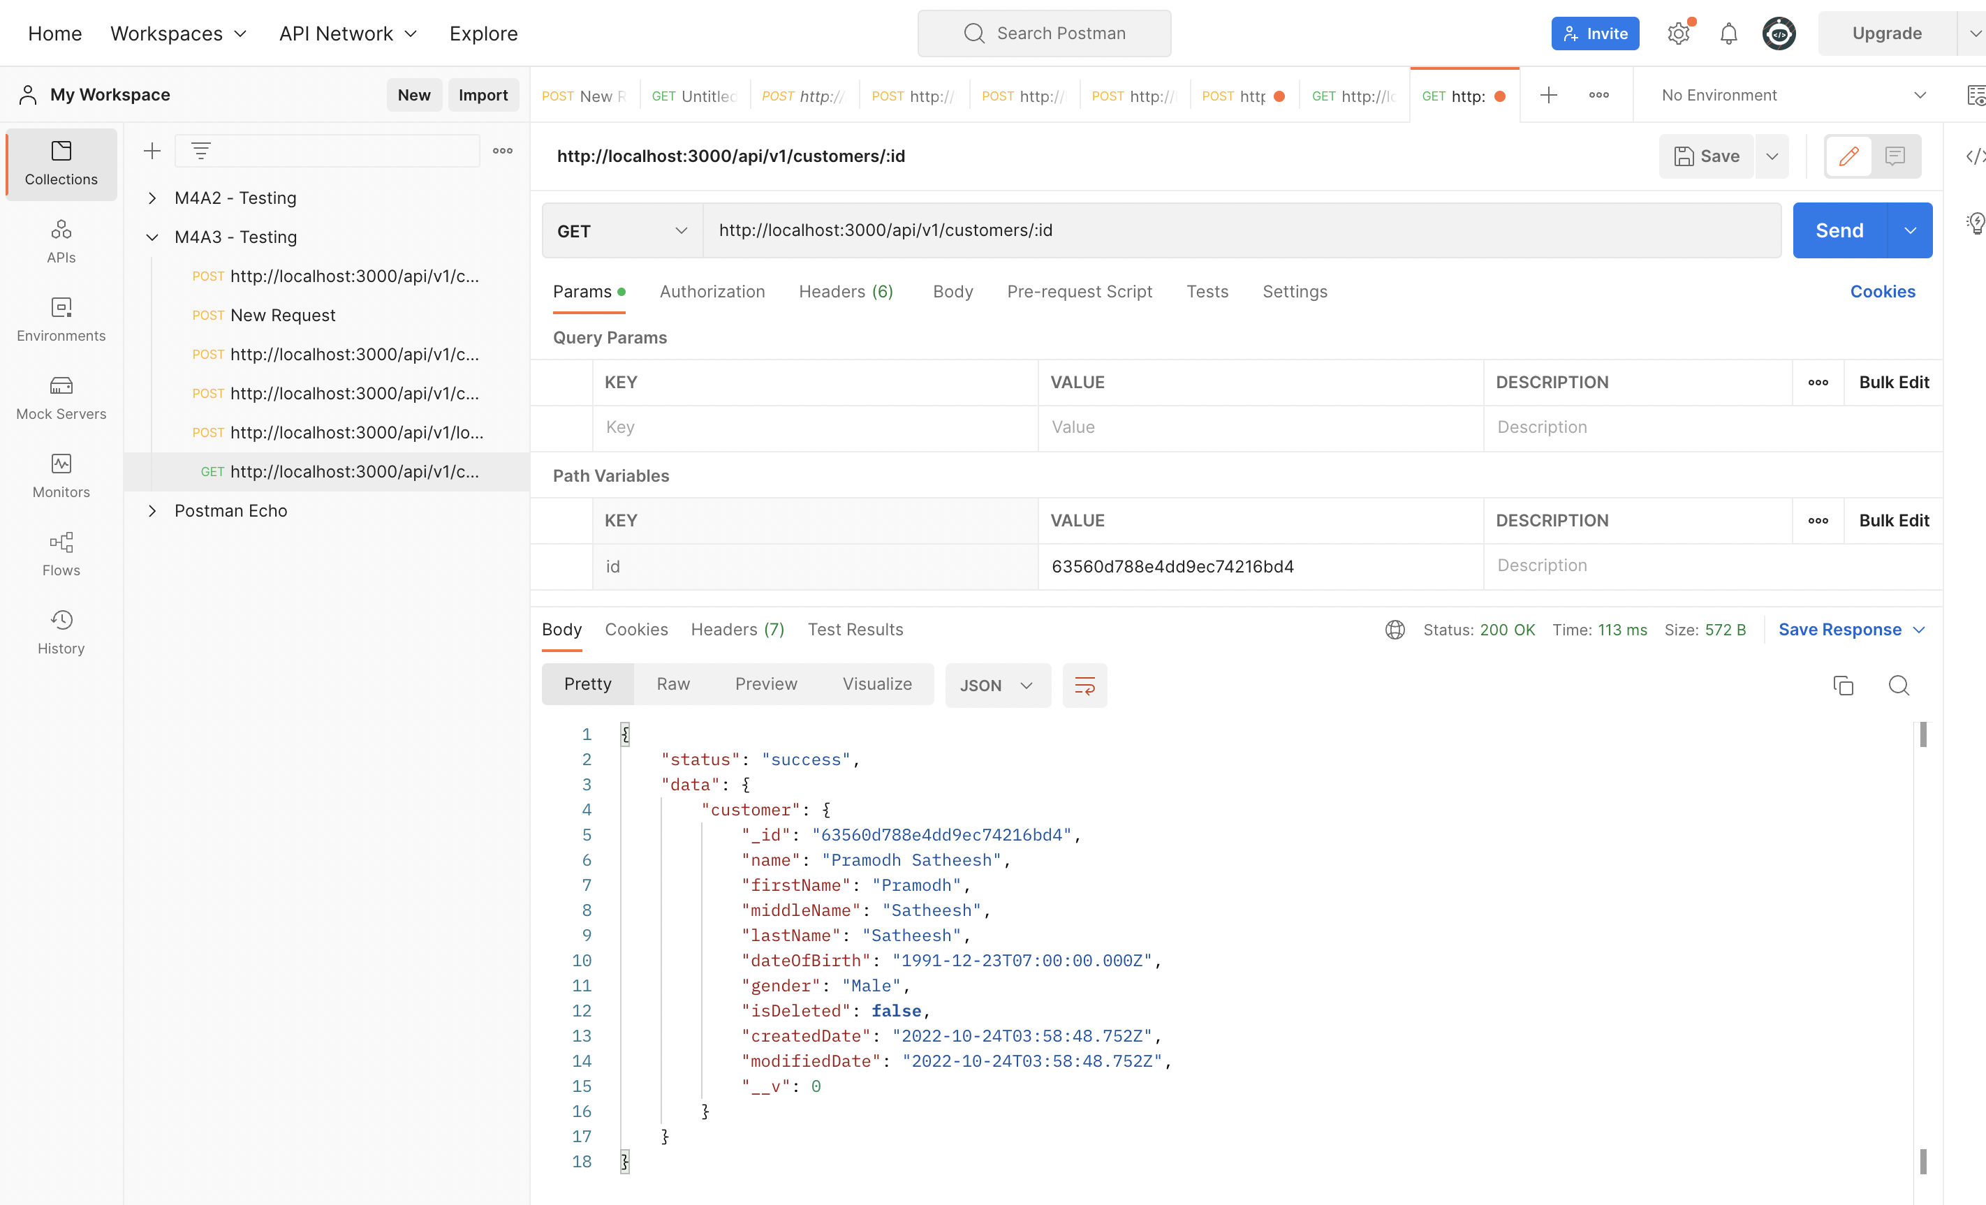

* **INSERT a new customer document**

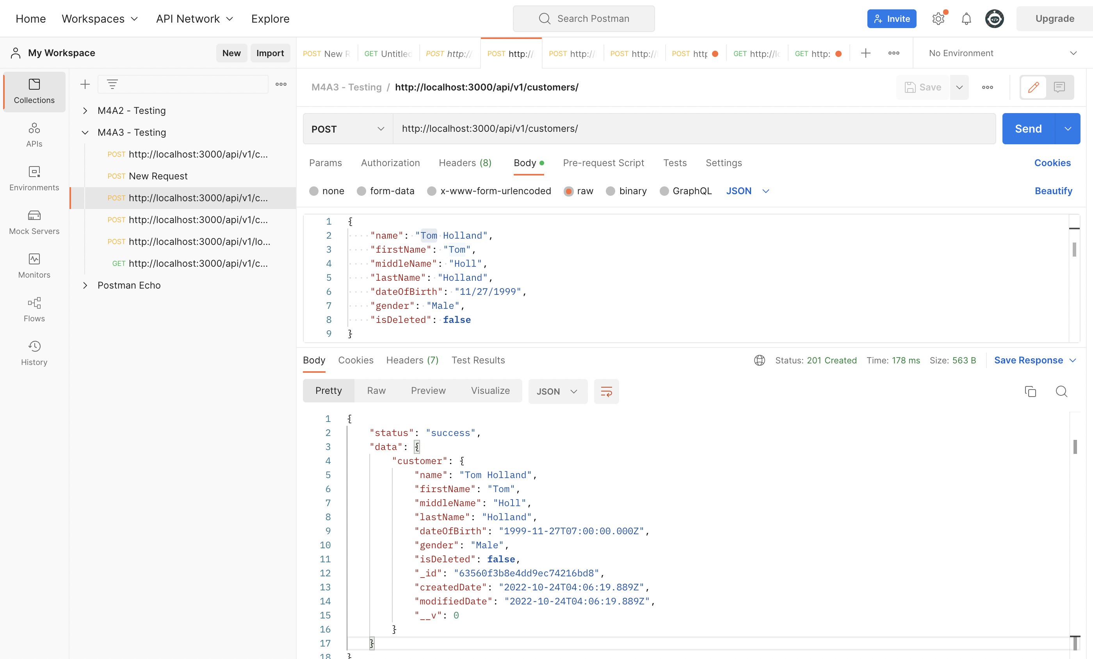

* **UPDATE an existing customer document**

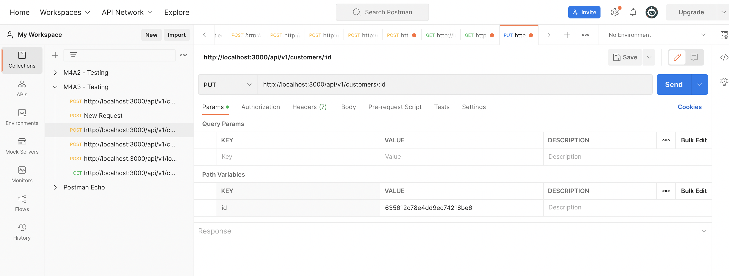

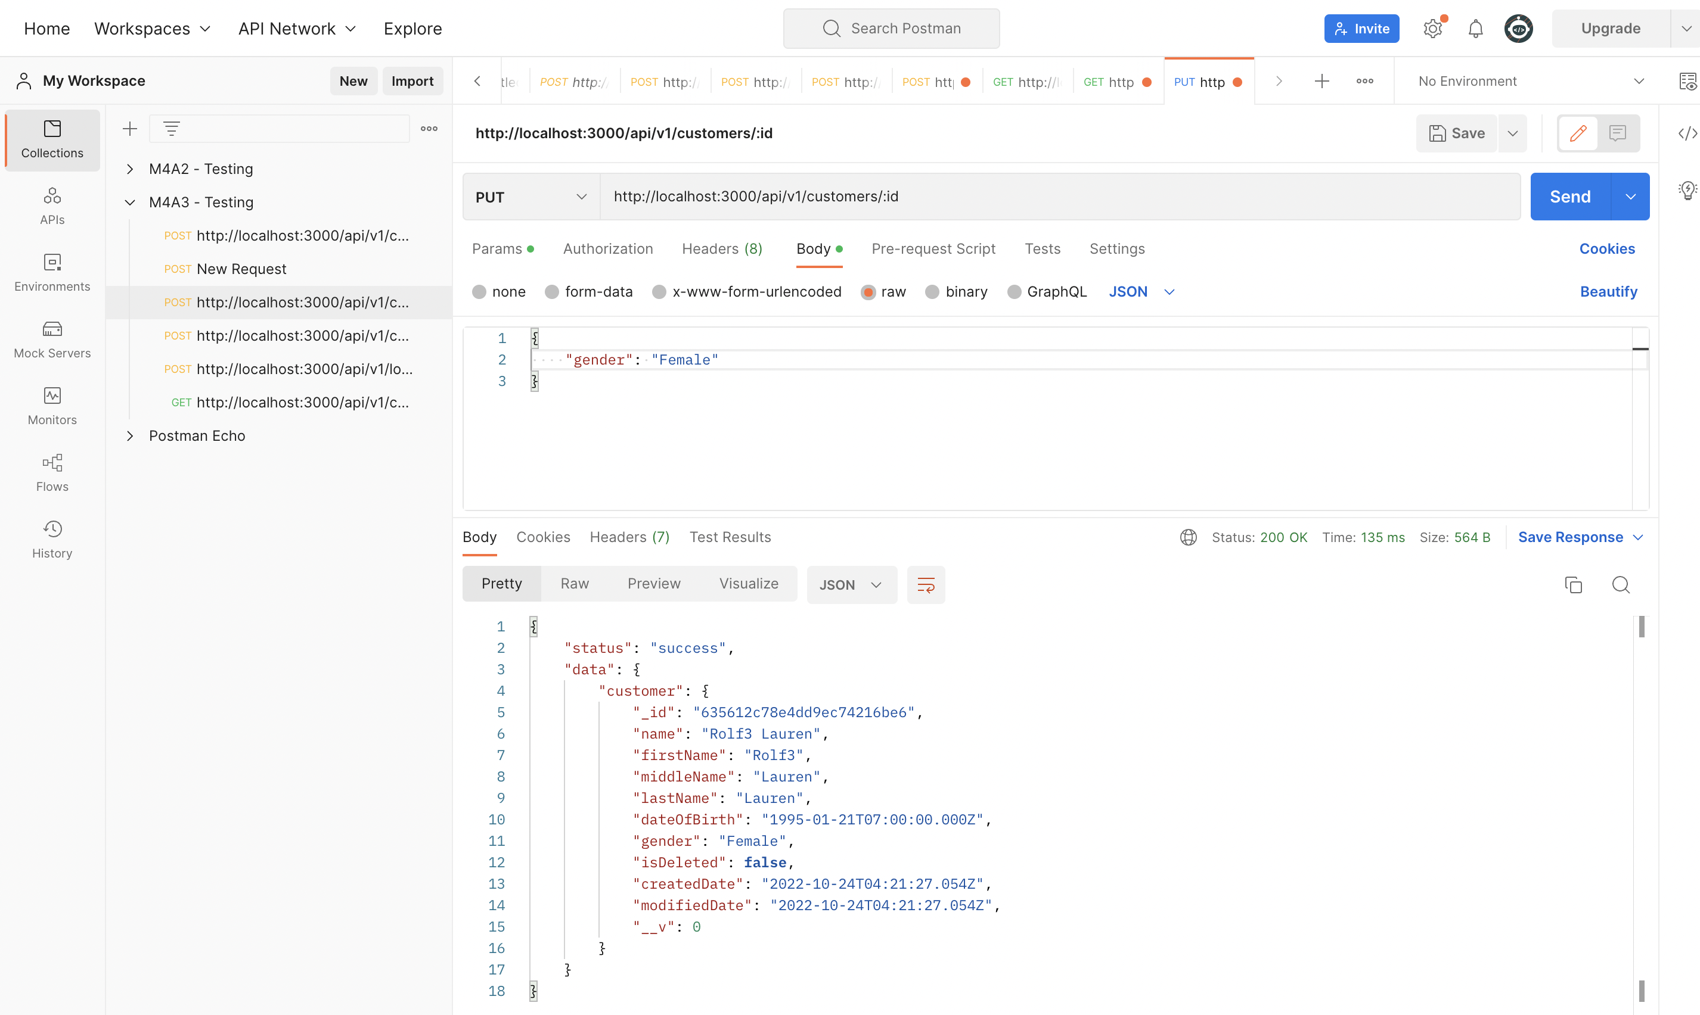

**DELETE an existing customer document**

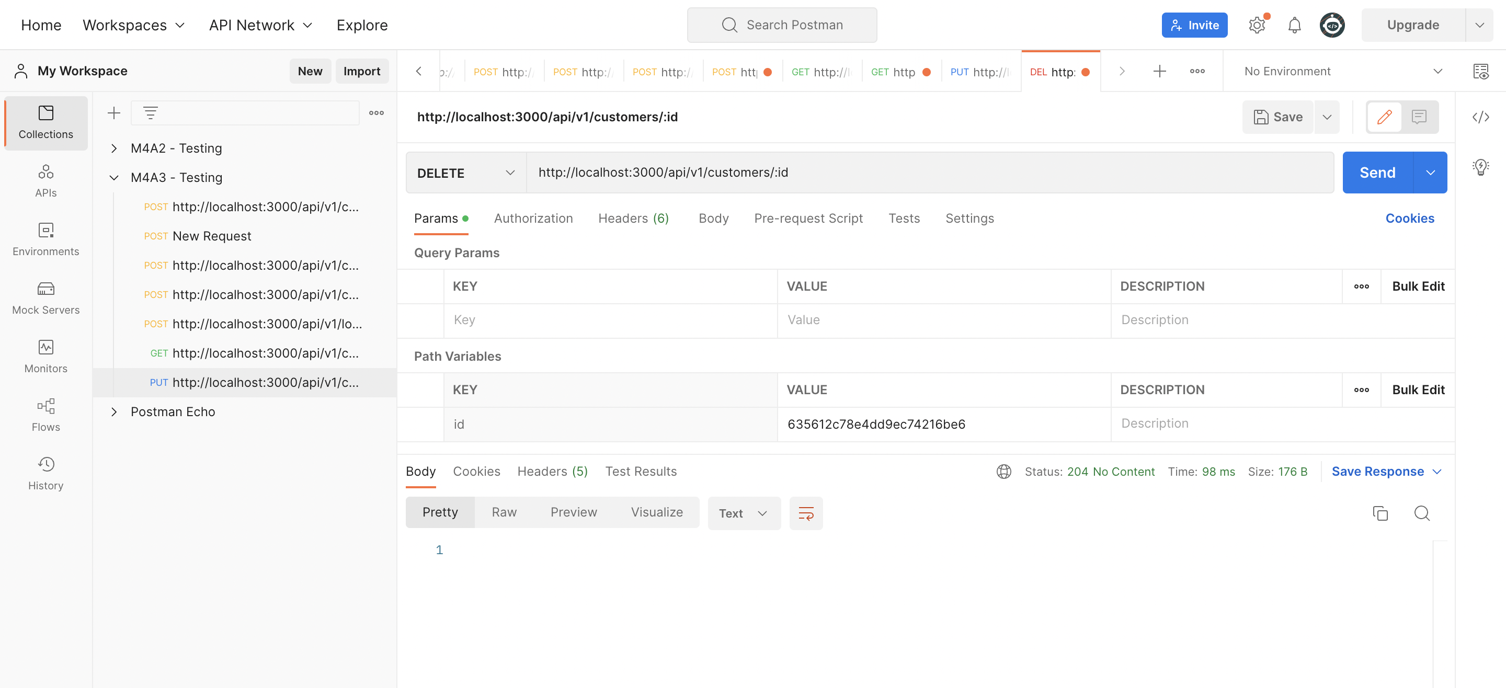

**Testing the loans collection:**

* **SELECT all the loans**

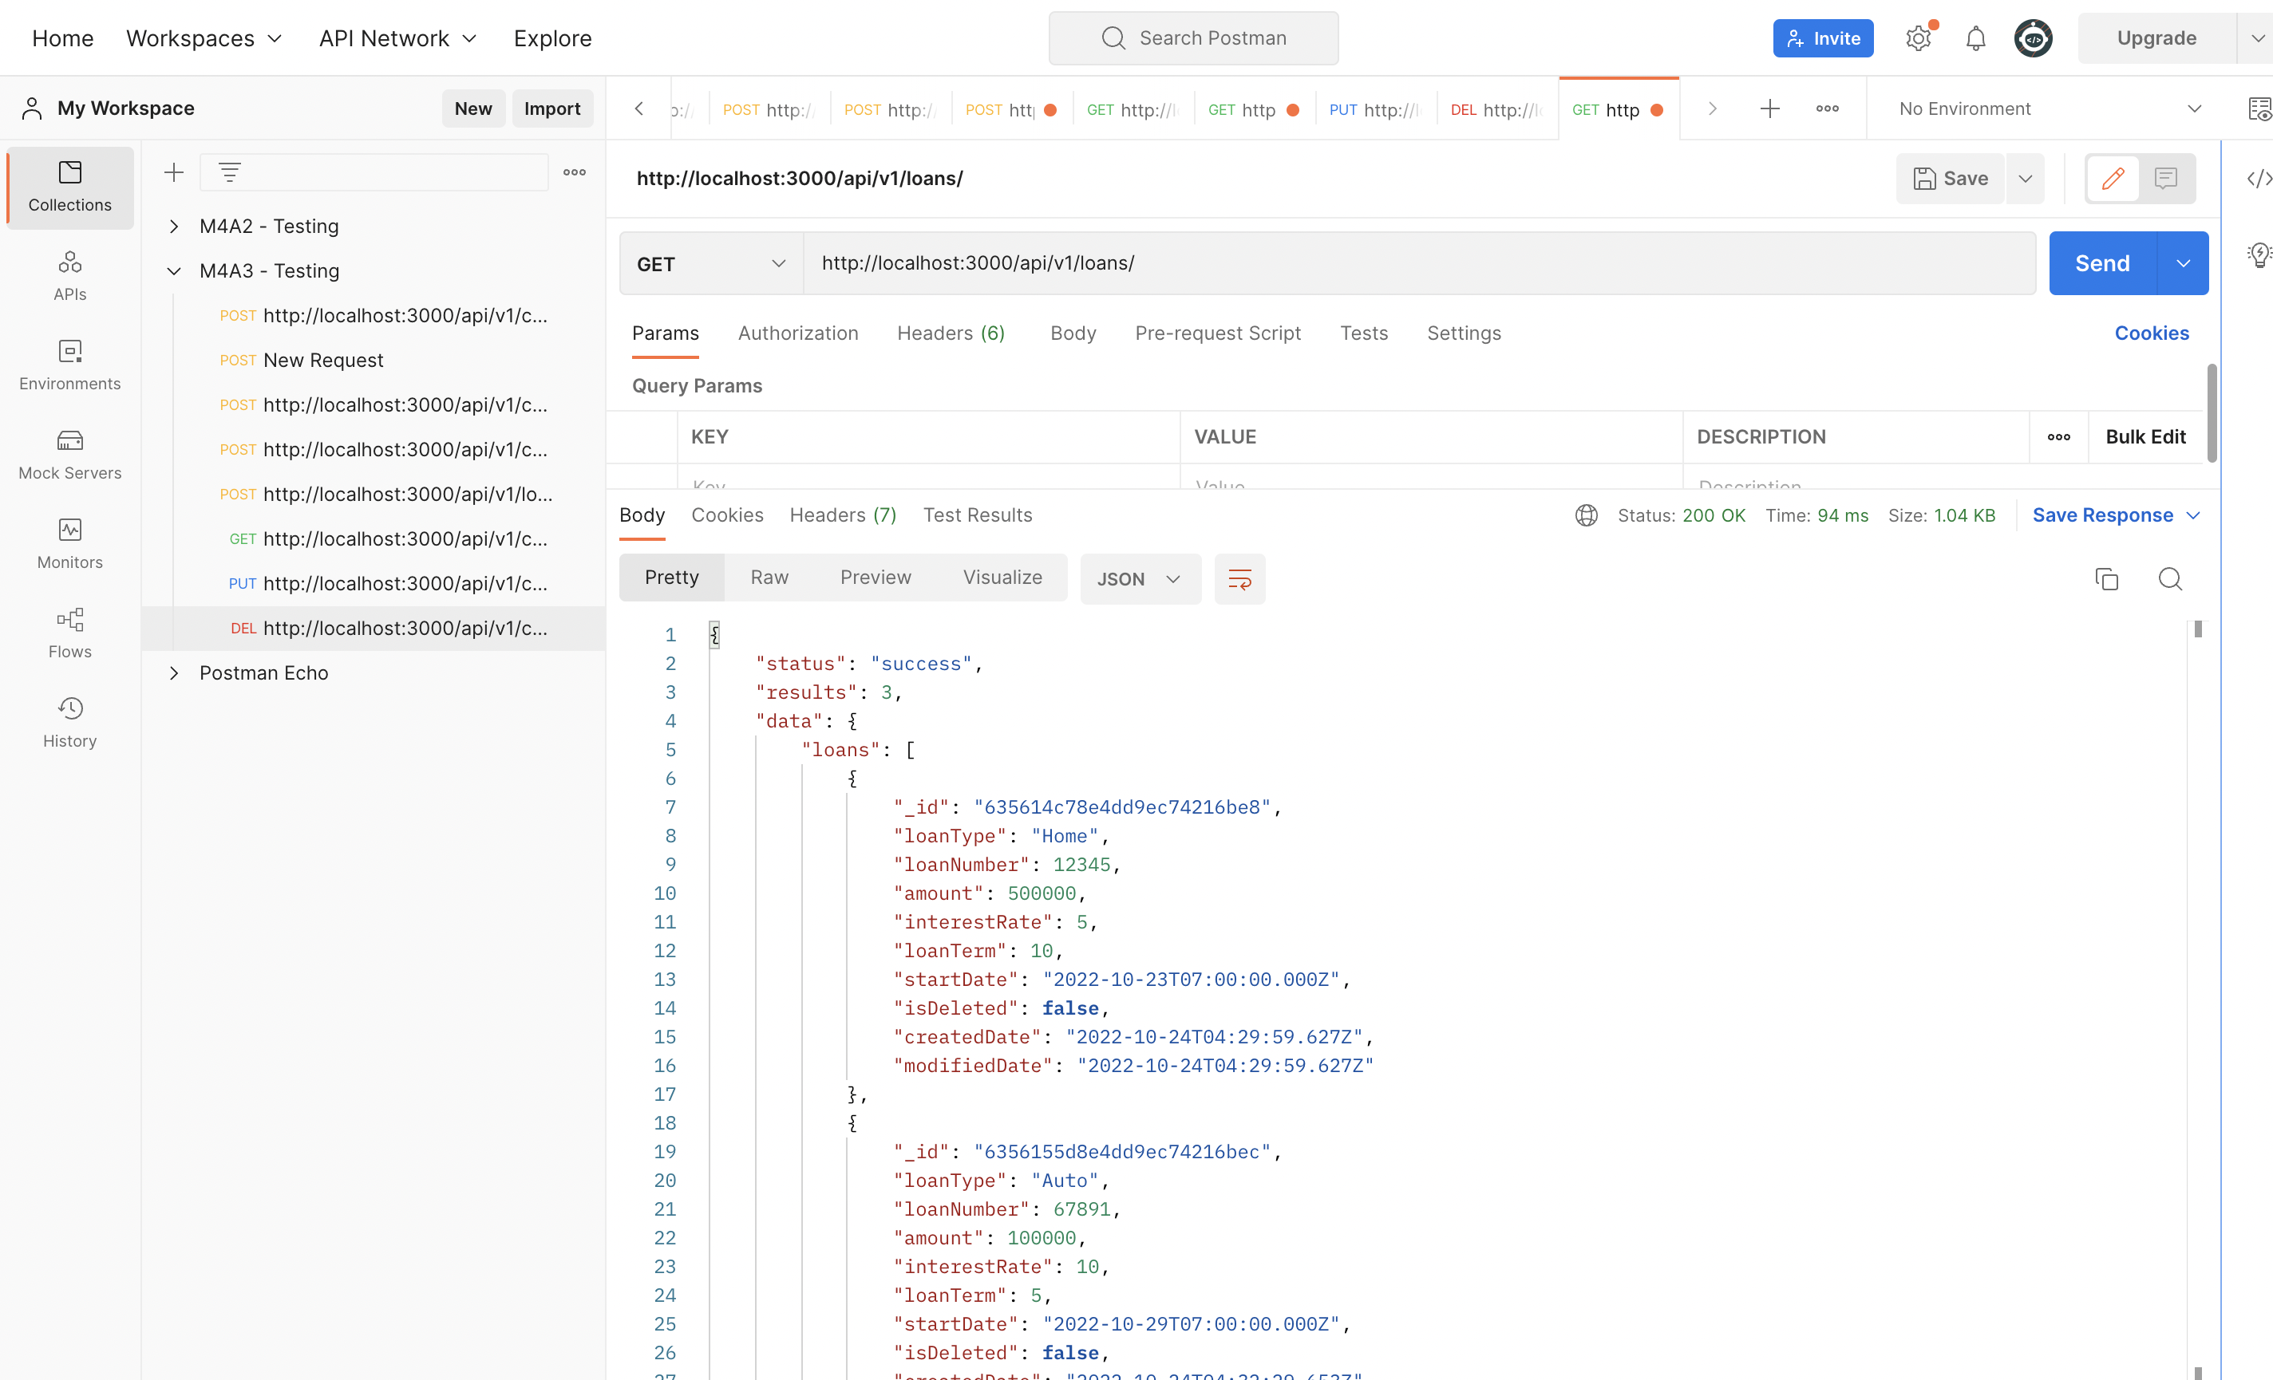

* **SELECT a loan based on the ID**

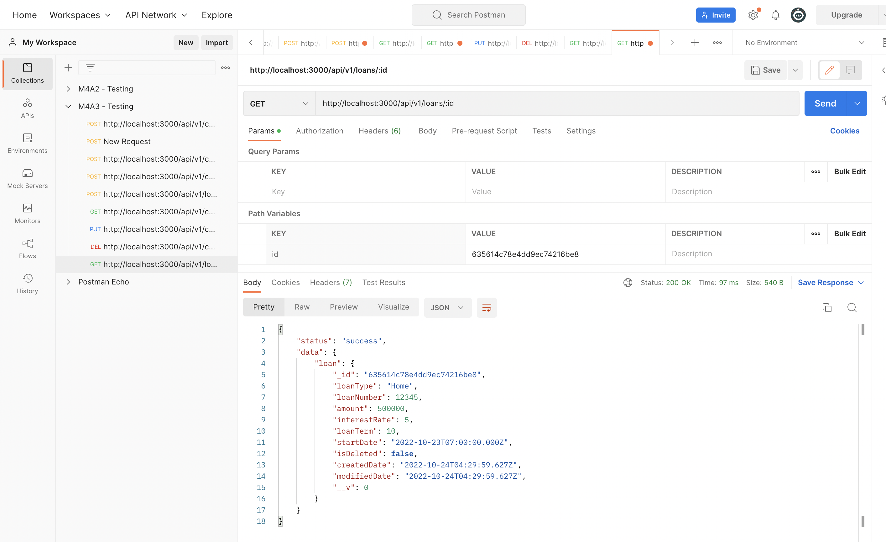

* **INSERT a new loan document**

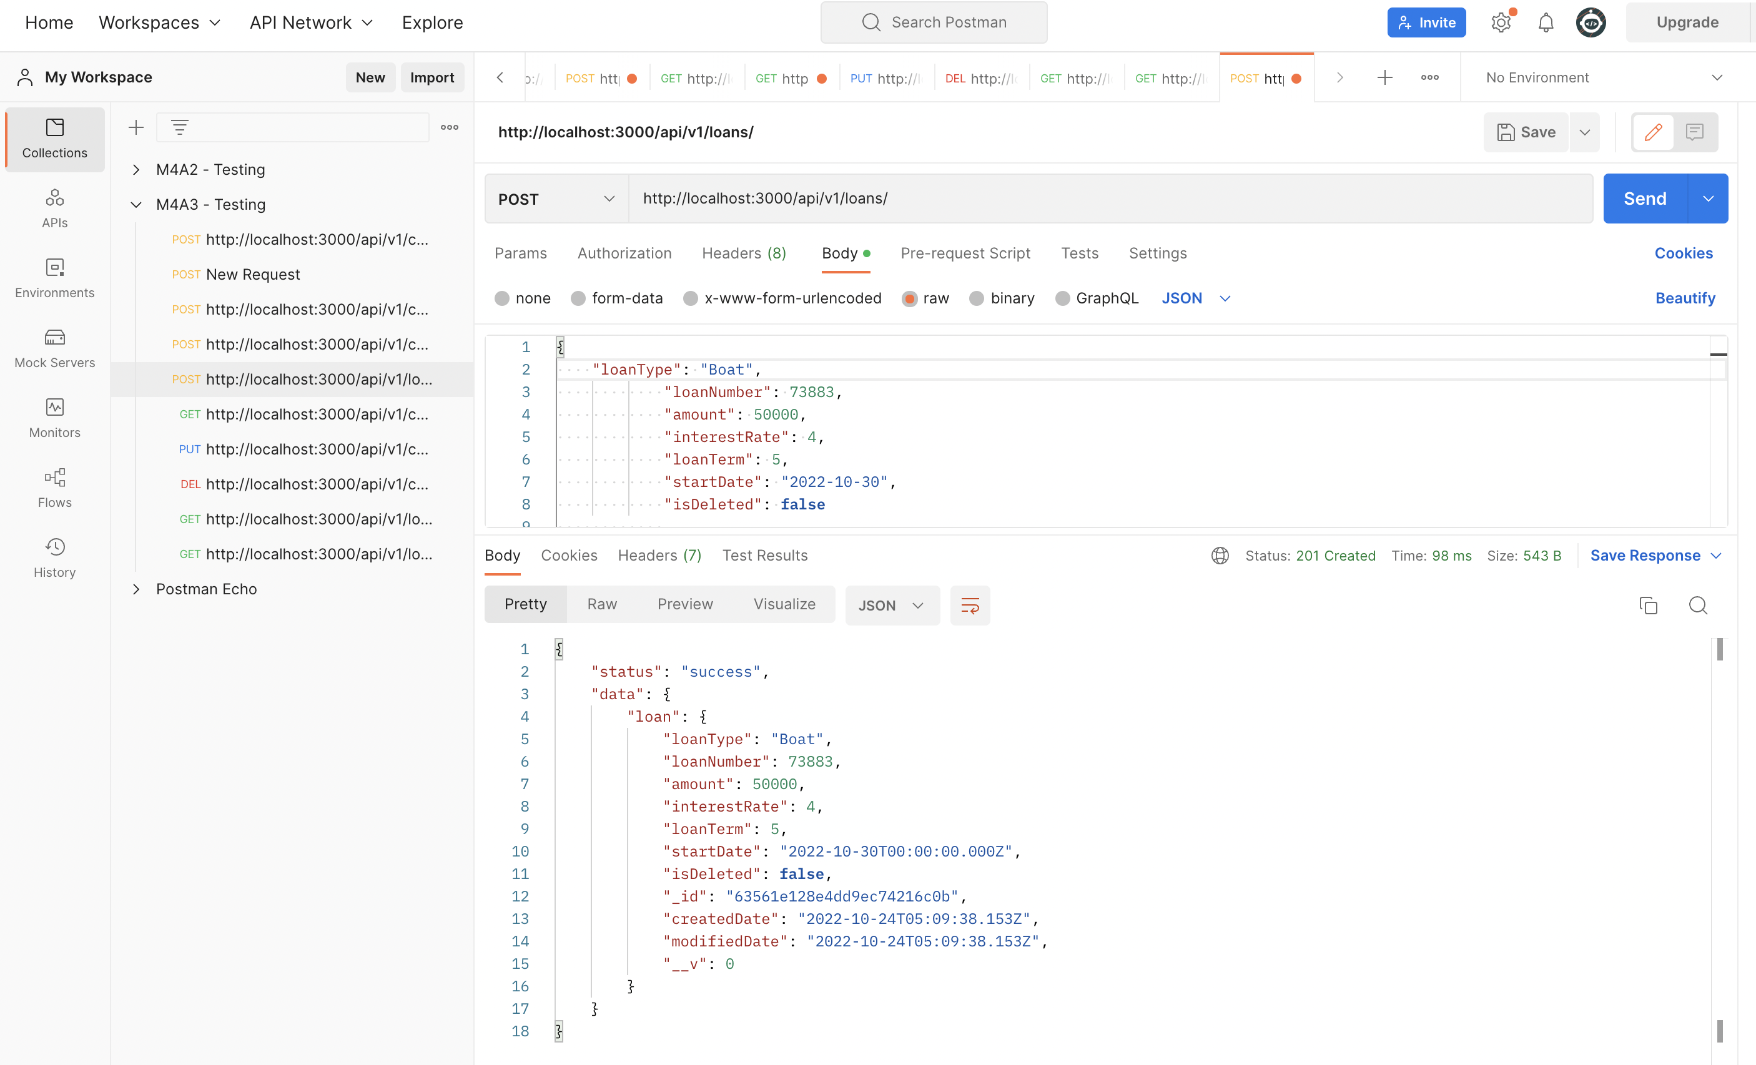

* **UPDATE an existing loan document**

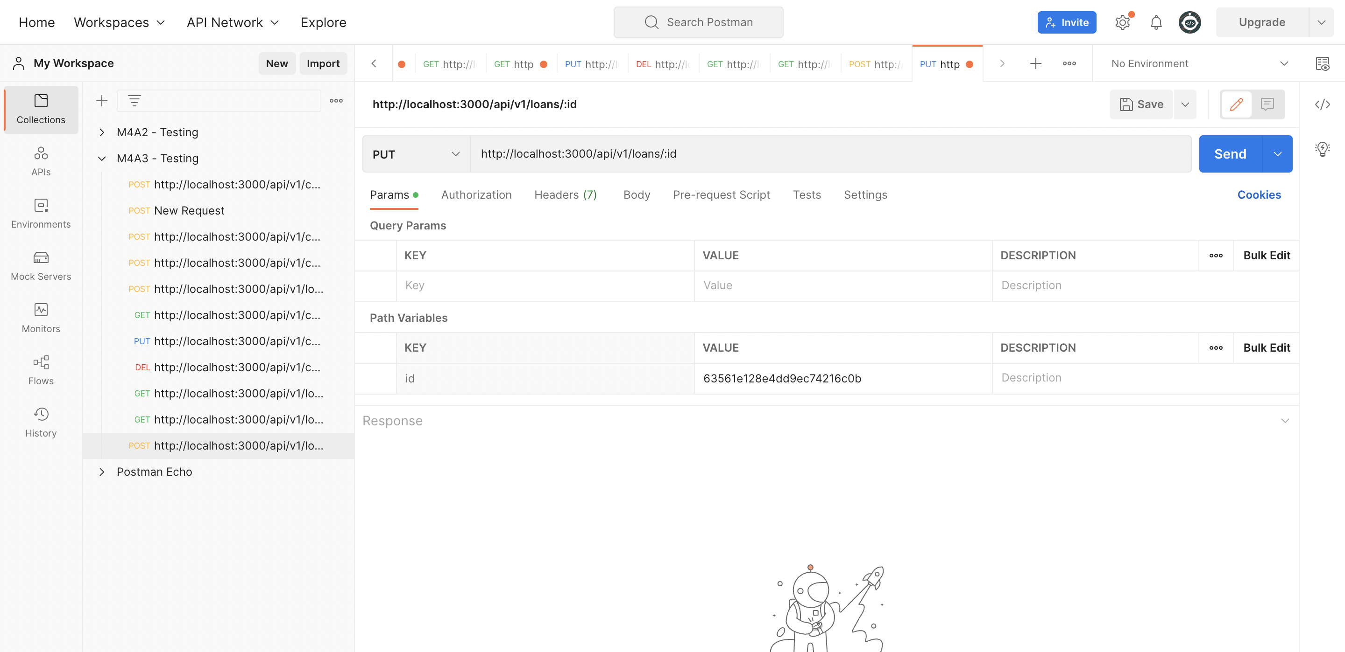

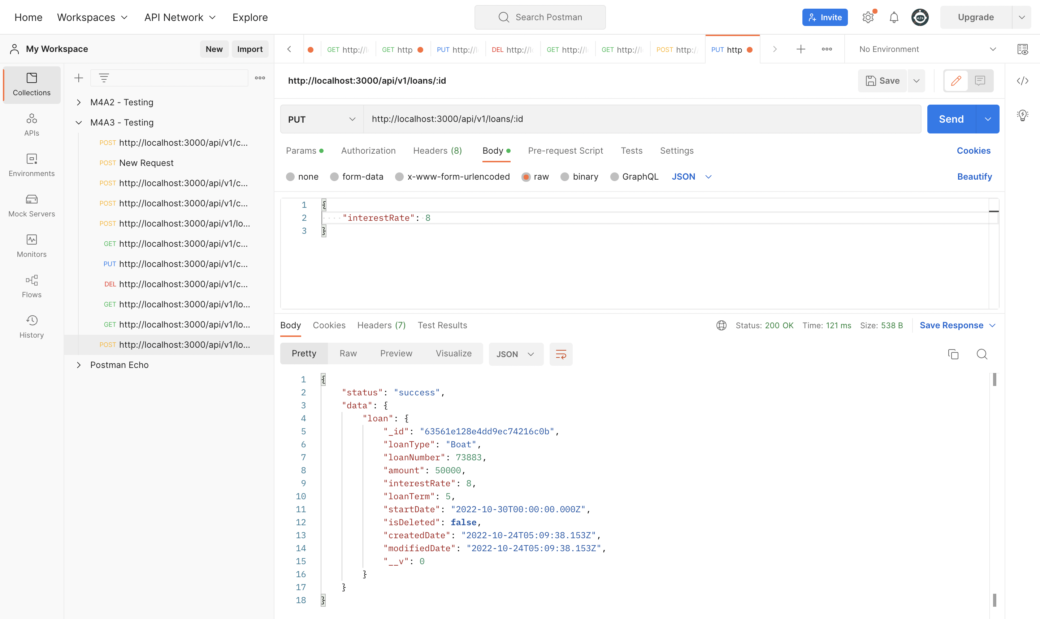

* **DELETE an existing loan document**

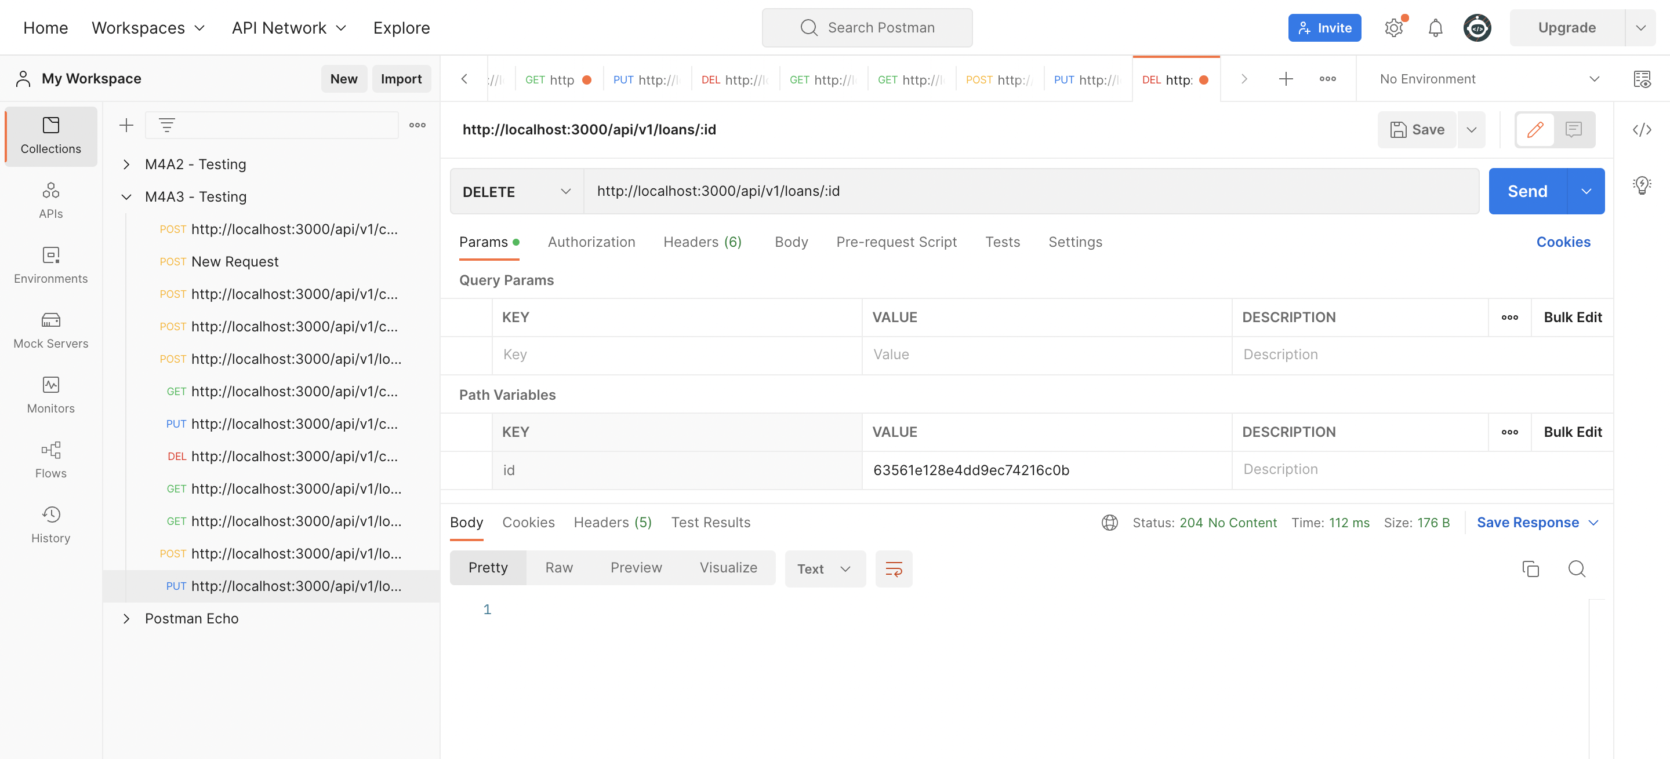

**Testing the loan_ledgers collection:**

* **SELECT all the loan ledgers**

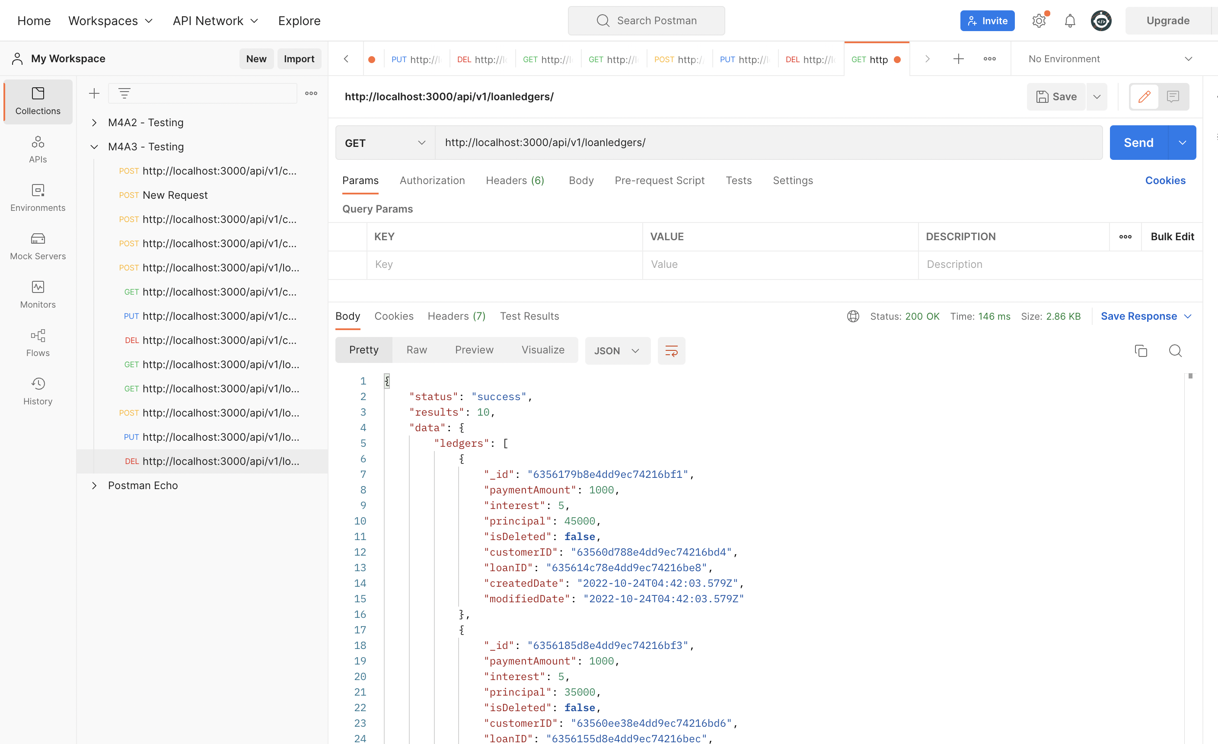

* **SELECT a loan ledger based on the ID**

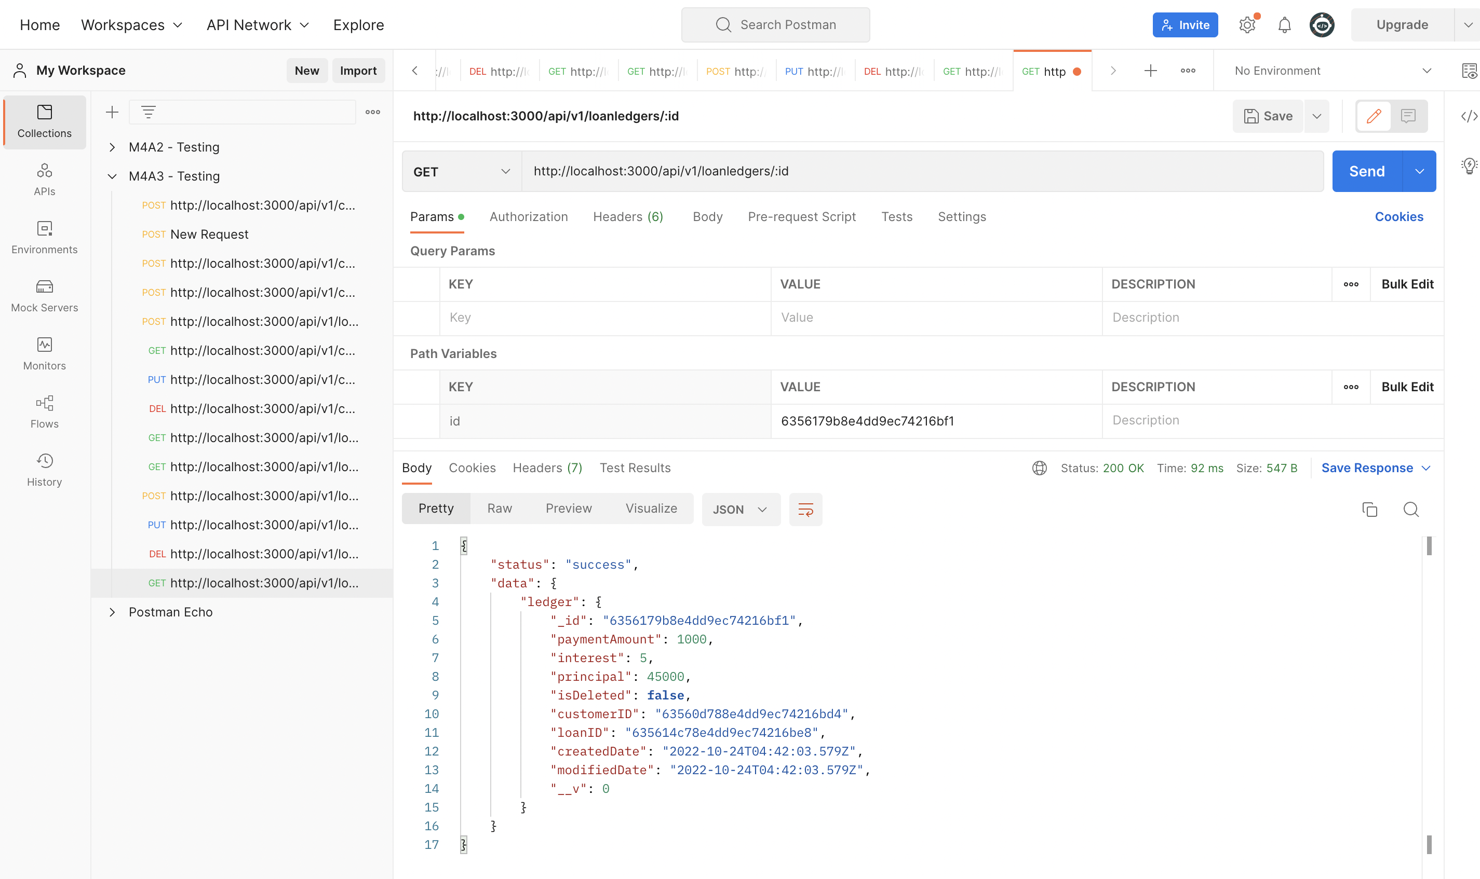

* **INSERT a new loan ledger document**

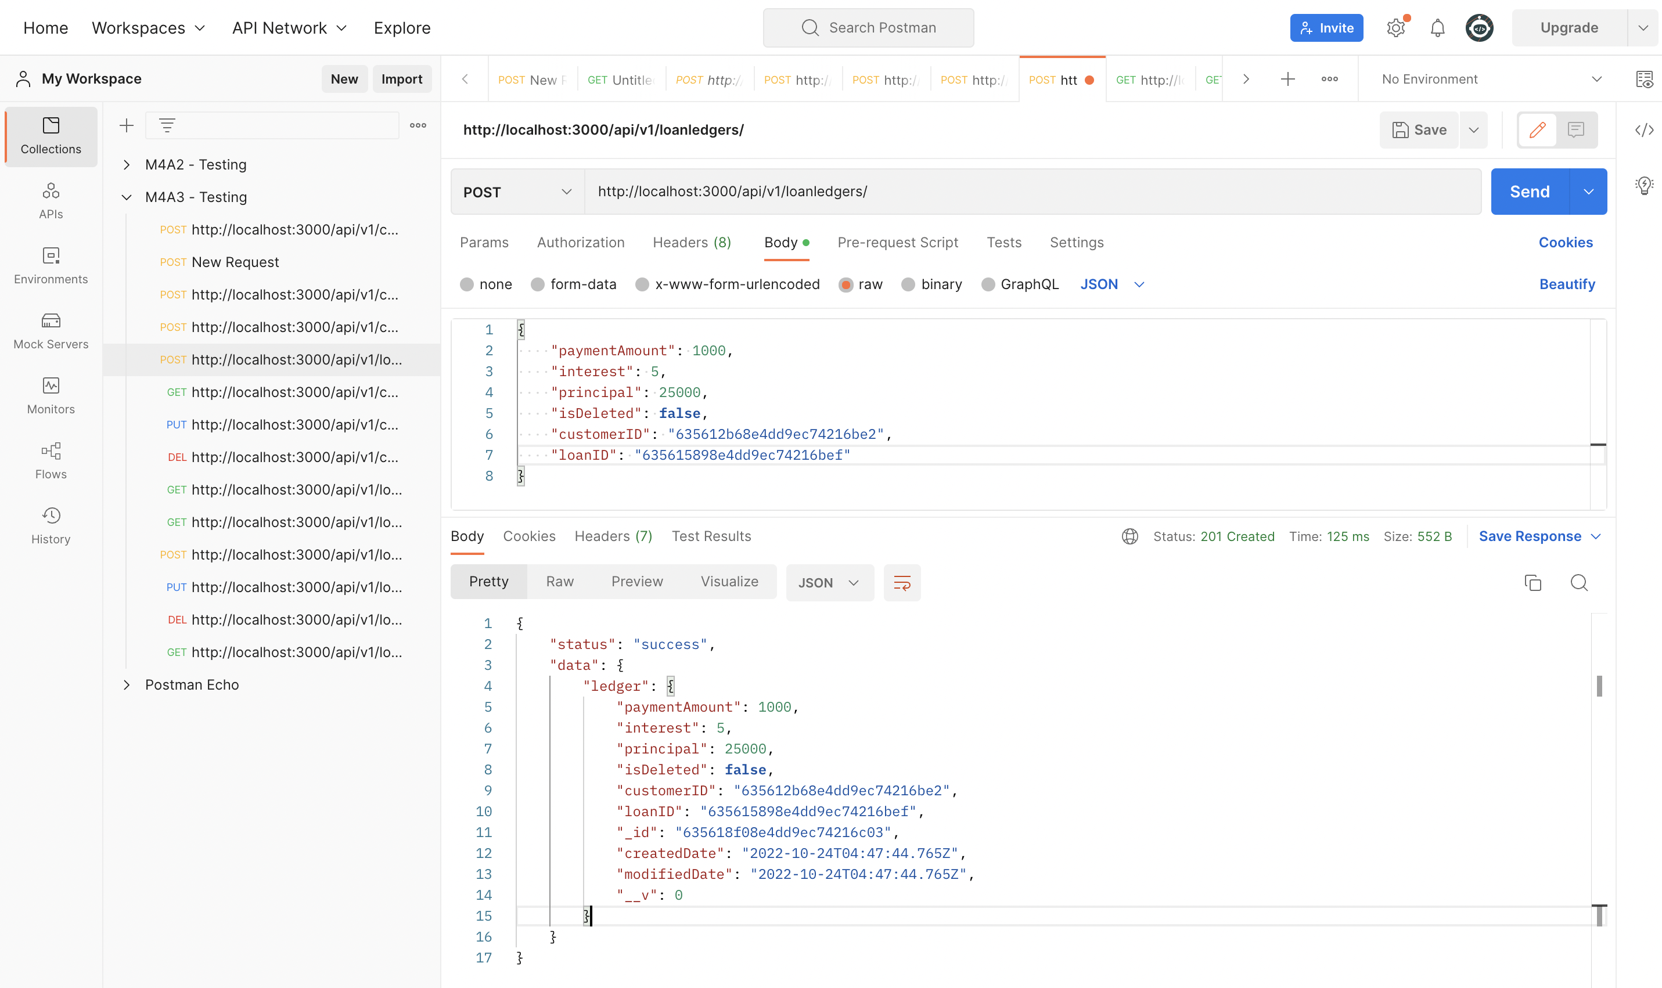

* **UPDATE an existing loan ledger document**

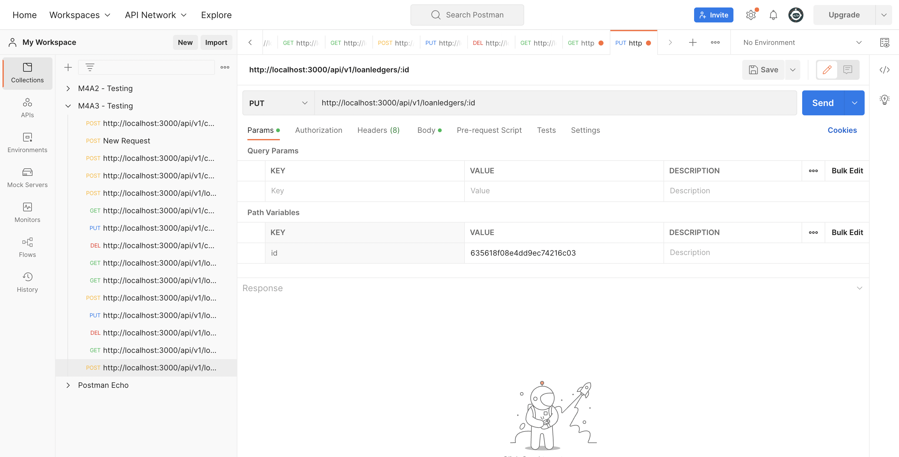

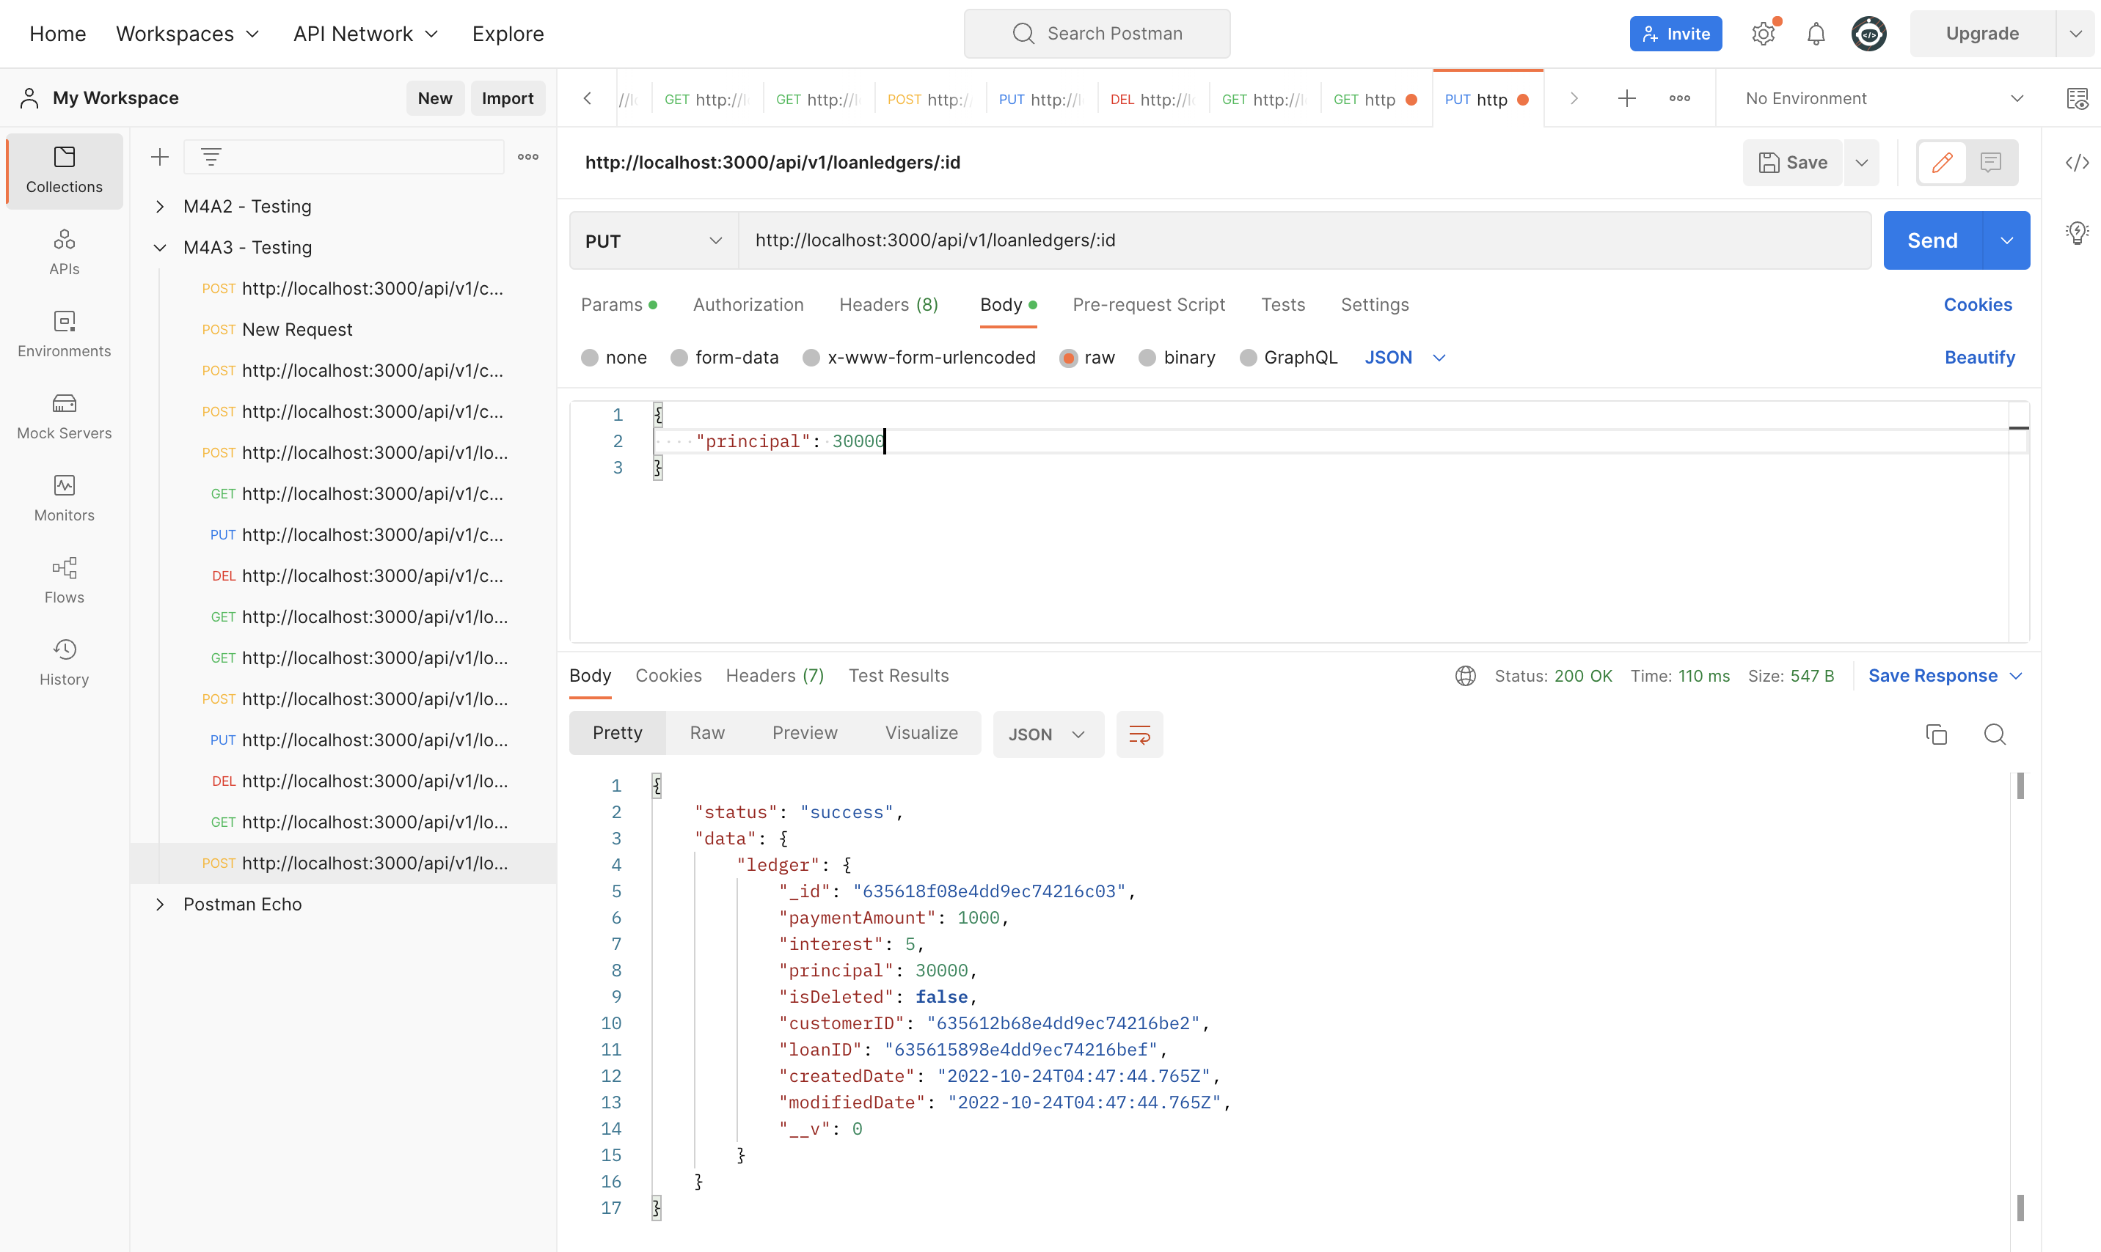

* **DELETE an existing loan ledger document**

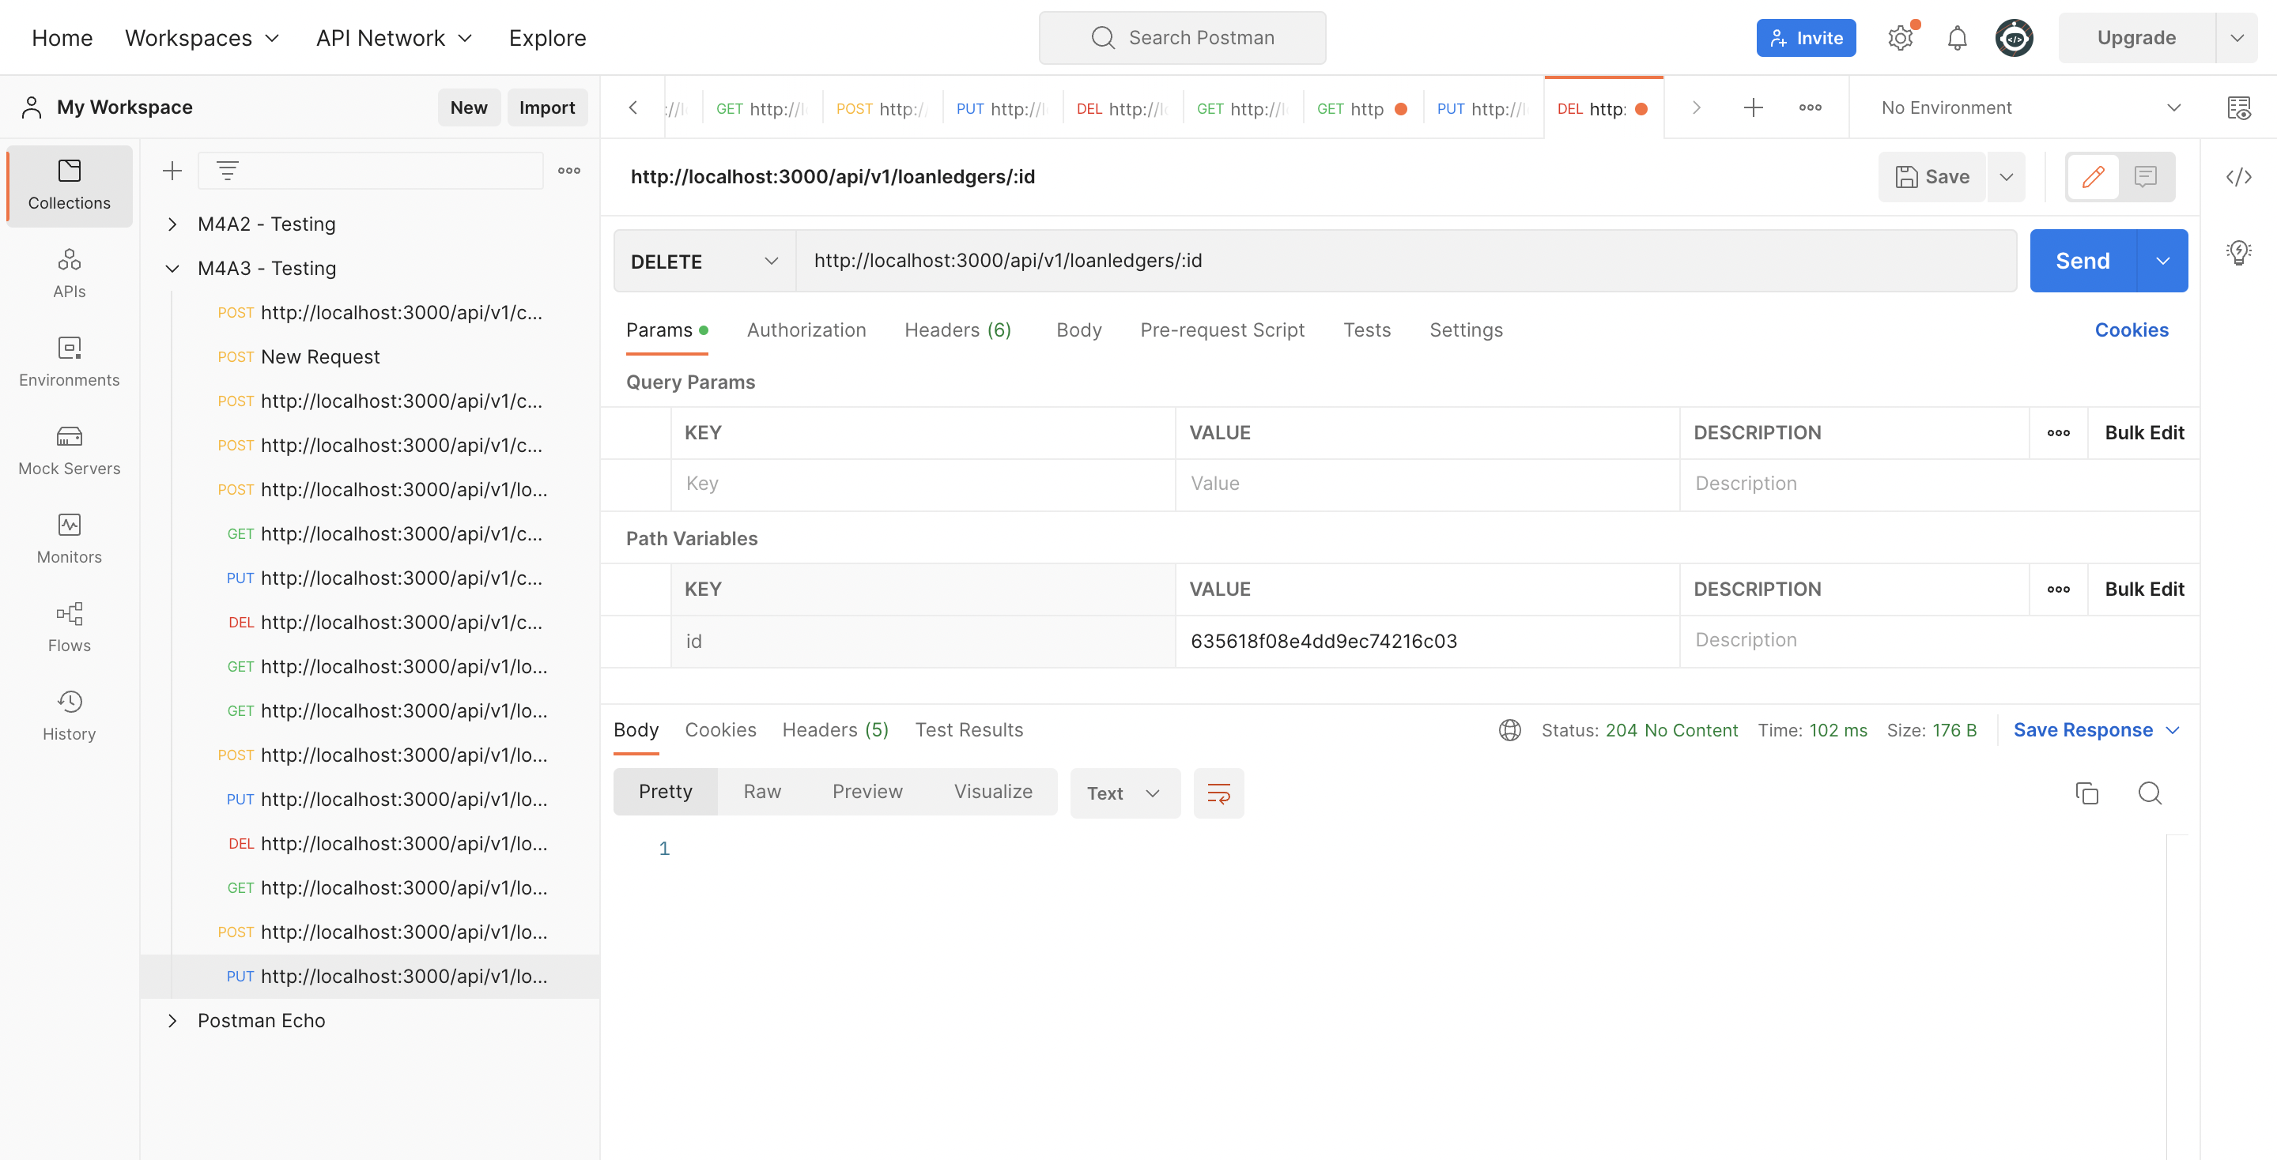

GitHub Link: